Data Blueprint Documentation

1-Data Path

Knowledge Base

1-Data path
# Source: AI Source: Provided by: [Data Path: Persons Table -> ID Column: 1, Name_En Column: Motasem Essam] -> From: [ChatGPT] on [7/14/2025]
A data path is a structured way to locate and reference specific data in a hierarchical storage system, such as folders, databases, tables, and columns. It shows the full route from the top-level folder down to the specific data value.

- A data path can reference any level:
  - Folder → Database → Table → Column: Value
  - Folder → Database → Table (entire table)
  - Folder → Database (entire database)
- Numbering is optional but useful for ordering or structured referencing.
- This makes it clear, unambiguous, and easy to track data locations.

2-Data Path Attributes
# Source: AI Source: Provided by: [Data Path: Persons Table -> ID Column: 1, Name_En Column: Motasem Essam] -> From: [ChatGPT] on [7/14/2025]
Data Path Attributes are the properties and metadata associated with a Data Path that describe, filter, and structure data references within hierarchical storage systems. They define how folders, databases, tables, columns, and values are accessed, filtered, grouped, and counted, making data references precise, unambiguous, and easy to interpret.
Note: All Data Path Attributes are optional. They can be included as needed to provide additional context, structure, or metadata, but a valid Data Path can exist without any attributes.

Rules and Guidelines

1-Data Path

Rules
# Source: AI Source: Provided by: [Data Path: Persons Table -> ID Column: 1, Name_En Column: Motasem Essam] -> From: [ChatGPT] on [7/14/2025]
- Folders Path
  - Start with the top-level folder and include all nested folders leading to the database.
  - •Use \ when referencing actual file system paths.
- Database Name
  - Specify the database where the table resides.
  - You can reference a single database or database tables within the same folder.
- Table Name
  - Include the table name(s) containing the data.
  - You can reference a single table or multiple tables within the same database.
- Column Name
  - Specify one or more column names if you want to reference specific fields.
  - You may reference:
    - A single column
    - Multiple columns
    - Any combination of columns and values
- Data Value
  - Include a value if you want to point to a specific record in the column.
  - You can reference single IDs, ranges, or multiple IDs/ranges combined, mixed combinations.
  - ID Syntax Examples
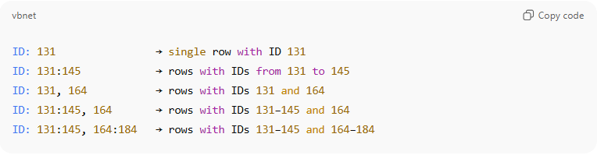
ID: 131 → single row with ID 131
ID: 131:145 → rows with IDs from 131 to 145
ID: 131, 164 → rows with IDs 131 and 164
ID: 131:145, 164 → rows with IDs 131–145 and 164
ID: 131:145, 164:184 → rows with IDs 131–145 and 164–184

  - You can combine any number of ranges and individual IDs, separated by commas.
  - Examples of flexible cases:
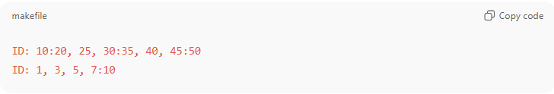
ID: 10:20, 25, 30:35, 40, 45:50
ID: 1, 3, 5, 7:10

- Record Group
- Columns inside a single { } group are combined using AND
- Each { } group is evaluated independently
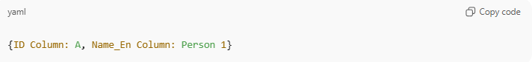
{ID Column: A, Name_En Column: Person 1}
Meaning:
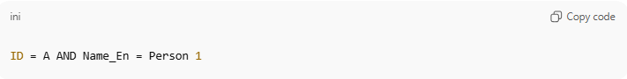
ID = A AND Name_En = Person 1
- Multiple { } groups under the same table are combined using OR
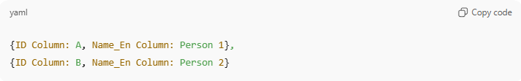
{ID Column: A, Name_En Column: Person 1},
{ID Column: B, Name_En Column: Person 2}
Meaning:
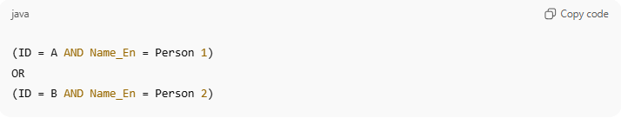
(ID = A AND Name_En = Person 1)
OR
(ID = B AND Name_En = Person 2)

- Numbering (Optional)
  - You may add numbering to folders, databases, or tables for ordering or referencing purposes.
    - Example: 1-Data Folder → 1-Data Database → 1-Tables Table -> ID: 1
    - Example: 1-Data Folder → 1-Data Database → 1-Tables Table -> ID: 1:3

Database Reference
# Source: AI Source: Provided by: [Data Path: Persons Table -> ID Column: 1, Name_En Column: Motasem Essam] -> From: [ChatGPT] on [7/14/2025]
Purpose:
A database reference points directly to a specific database within a folder hierarchy

Syntax:
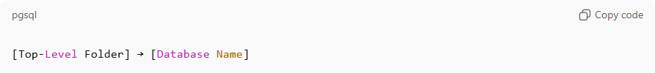
[Top-Level Folder] → [Database Name]

Rules:
- → separates folder names from the database.
- Multiple databases in the same folder can be separated with :: (double colon).
- databases are listed after folder.
- The folder can be omitted if the database is uniquely identifiable.•

Examples:
Single database in a top-level folder: 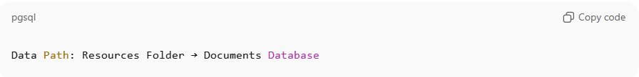
Data Path: Resources Folder → Documents Database

Multiple databases in the same folder: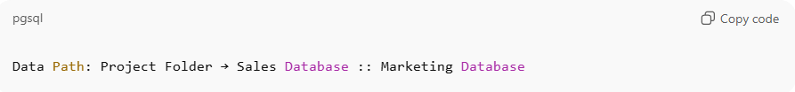
Data Path: Project Folder → Sales Database :: Marketing Database

Single database reference without folder:
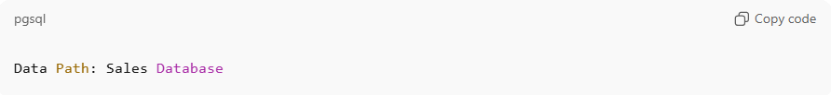
Data Path: Sales Database

Table Reference
# Source: AI Source: Provided by: [Data Path: Persons Table -> ID Column: 1, Name_En Column: Motasem Essam] -> From: [ChatGPT] on [7/14/2025]
Purpose:
A table reference points directly to one or more tables within a specific database

Syntax:
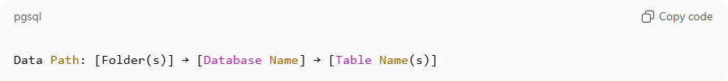
Data Path: [Folder(s)] → [Database Name] → [Table Name(s)]

Rules:
- → separates folder names from the database and the database from tables.
- databases are listed after folder.
- Multiple tables in the same database can be separated with | (pipe).
- Each table is listed per database
- The folder or database can be omitted if the table is uniquely identifiable.

Examples:
Single table in a database:
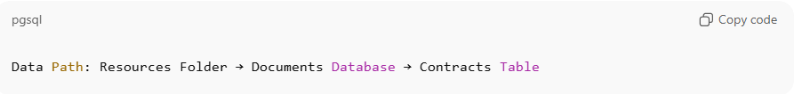
Data Path: Resources Folder → Documents Database → Contracts Table

Multiple tables in the same database:
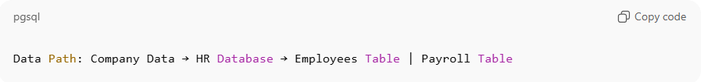
Data Path: Company Data → HR Database → Employees Table | Payroll Table

Multiple tables in multiple database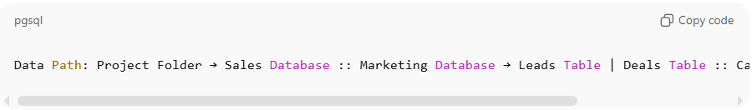
Data Path: Project Folder → Sales Database :: Marketing Database → Leads Table | Deals Table :: Campaigns Database → Ads Table

Single table in a database without folder:
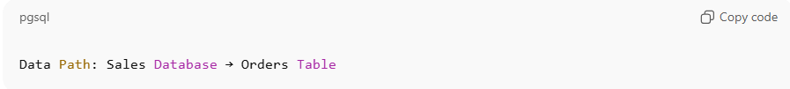
Data Path: Sales Database → Orders Table

Single Table with a specific column and value without folder and without Database:
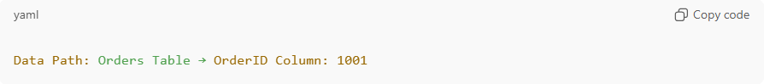
Data Path: Orders Table → OrderID Column: 1001

Column Reference
# Source: AI Source: Provided by: [Data Path: Persons Table -> ID Column: 1, Name_En Column: Motasem Essam] -> From: [ChatGPT] on [7/14/2025]
Purpose:
A column reference points directly to one or more columns
within

Syntax:
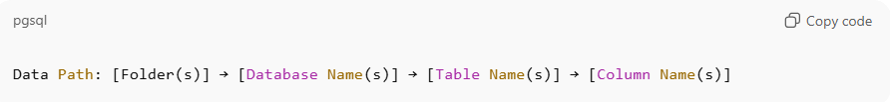
Data Path: [Folder(s)] → [Database Name(s)] → [Table
Name(s)] → [Column Name(s)]

Rules:
- → separates folders from databases, databases from tables, and tables from columns.
- Multiple databases in the same folder: :: (double colon).
- databases are listed after folder.
- Multiple tables in the same database: | (pipe).
- tables are listed after database.
- Multiple columns in the same table: , (comma).
- Columns are listed after table

Examples:
Single column in a single table:
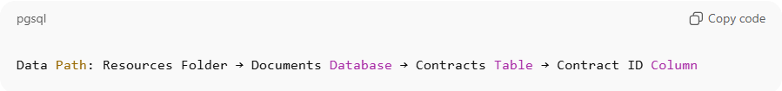
Data Path: Resources Folder → Documents Database → Contracts Table → Contract ID Column

Multiple columns in a single table:
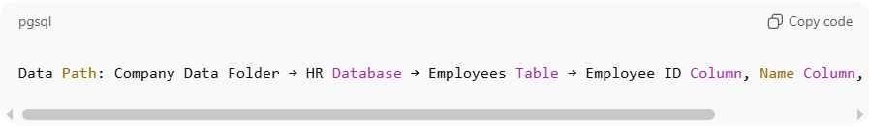
Data Path: Company Data Folder → HR Database → Employees Table → Employee ID Column, Name Column, Department Column

Columns across multiple tables in a single database:
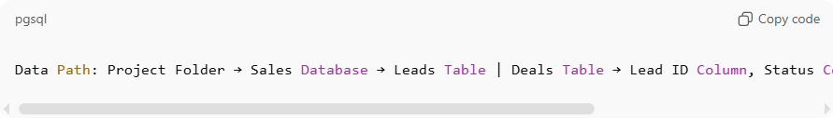
Data Path: Project Folder → Sales Database → Leads Table | Deals Table → Lead ID Column, Status Column | Deal Table → Deal ID Column, Amount Column

Columns across multiple tables in multiple databases:
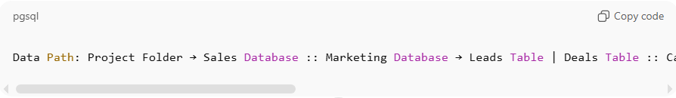
Data Path: Project Folder → Sales Database :: Marketing Database → Leads Table | Deals Table :: Campaigns Database → Campaigns Table → Campaigns ID Column, Status Column | Deal Table → Deal ID Column, Amount Column :: Ads Database → Ads Table → Ad ID Column, Campaign ID Column

✅ Explanation:
- Databases: Sales Database, Marketing Database, Campaigns Database, Ads Database
- Tables and columns per database:
  - Sales Database: Leads Table (no columns specified) | Deals Table (no columns specified)
  - Marketing Database: Campaigns Table → Campaigns ID Column, Status Column | Deal Table → Deal ID Column, Amount Column
  - Ads Database: Ads Table → Ad ID Column, Campaign ID Column
- → separates hierarchy levels.
- | separates multiple tables within the same database.
- :: separates multiple databases.
- , separates multiple columns within the same table.

Data Value Reference
# Source: AI Source: Provided by: [Data Path: Persons Table -> ID Column: 1, Name_En Column: Motasem Essam] -> From: [ChatGPT] on [7/14/2025]
Purpose:
A data value reference points directly to one or more specific records in a column. It is the most detailed level in a Data Path hierarchy.

Syntax:
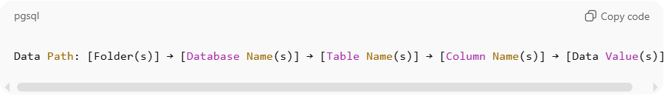
Data Path: [Folder(s)] → [Database Name(s)] → [Table Name(s)] → [Column Name(s)] → [Data Value(s)]

Rules:
- → separates hierarchy levels: folder → database → table → column → value.
- :: separates multiple databases.
- | separates multiple tables within the same database.
- , separates multiple columns within the same table or multiple values within the same column.
- The column name is immediately followed by : and then the value(s).
- : indicates a range of values.
- Multiple columns act like filters combined together
- All other columns use exact matching
- Order of columns does NOT matter
- Combining ID ranges with another column

Examples:
Single value in a single column:
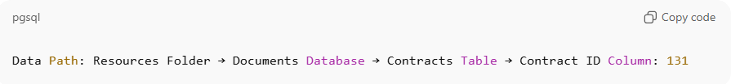
Data Path: Resources Folder → Documents Database → Contracts Table → Contract ID Column: 131

Multiple values in a single column:
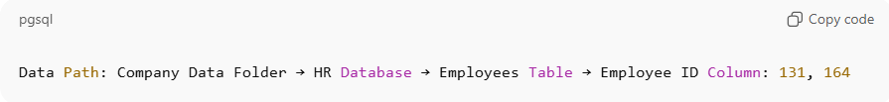
Data Path: Company Data Folder → HR Database → Employees
Table → Employee ID Column: 131, 164

Range of values in a single column:
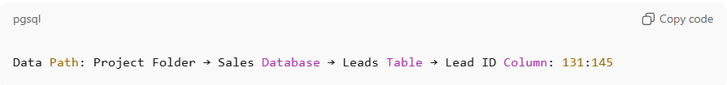
Data Path: Project Folder → Sales Database → Leads Table → Lead ID Column: 131:145

Combination of ranges and individual values:
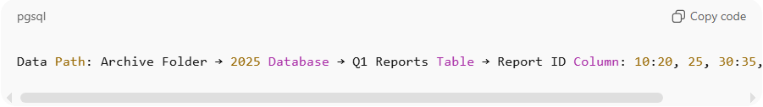
Data Path: Archive Folder → 2025 Database → Q1 Reports Table → Report ID Column: 10:20, 25, 30:35, 40, 45:50

Values across multiple columns, tables, and databases:
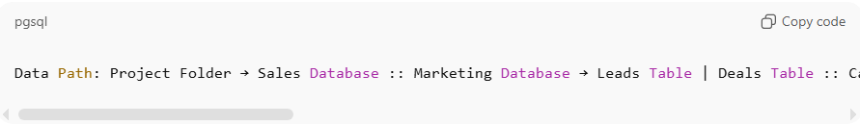
Data Path: Project Folder → Sales Database :: Marketing Database → Leads Table | Deals Table :: Campaigns Database → Campaigns Table → Campaign ID Column, Status Column | Deal Table → Deal ID Column, Amount Column :: Ads Database → Ads Table → Ad ID Column, Campaign ID Column: 101, 102, 201:205

✅ Explanation of Example 5:
- Databases: Sales Database, Marketing Database, Campaigns Database, Ads Database
- Tables and columns per database:
  - Sales Database: Leads Table (no values) | Deals Table (no values)
  - Marketing Database: Campaigns Table → Campaign ID Column, Status Column | Deal Table → Deal ID Column, Amount Column
  - Ads Database: Ads Table → Ad ID Column, Campaign ID Column: 101, 102, 201:205
- , separates multiple values or columns.
- : represents a range of values.
- | separates tables.
- :: separates databases.

Rule: Multiple columns act like filters combined together:
- When you write multiple columns, they are interpreted as:
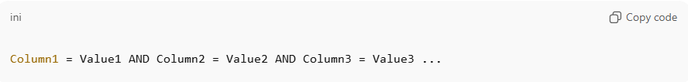
Column1 = Value1 AND Column2 = Value2 AND Column3 = Value3 ...

Example:
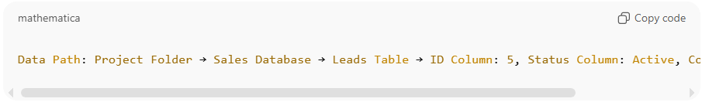
Data Path: Project Folder → Sales Database → Leads Table → ID Column: 5, Status Column: Active, Country Column: USA

✅ Explanation
Row must match all conditions at the same time.
Meaning: Only rows where ID = 5 AND Status = Active AND
Country = USA will be matched so

Rule: All other columns use exact matching
- Values must match exactly for filtering.

Example:
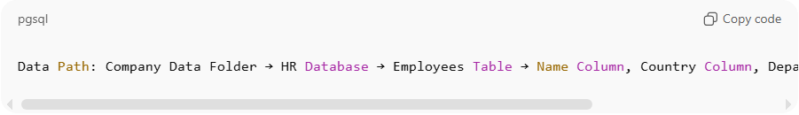
Data Path: Company Data Folder → HR Database → Employees Table → Name Column, Country Column, Department Column: John, UK, Sales

✅ Explanation
Meaning: Only rows where:
- Name = John
- AND Country = UK
- AND Department = Sales

Rule: Order of columns does NOT matter
- Columns can be listed in any order; the filter logic remains the same.

Examples:
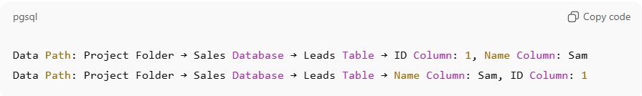
Data Path: Project Folder → Sales Database → Leads Table → ID Column: 1, Name Column: Sam
Data Path: Project Folder → Sales Database → Leads Table → Name Column: Sam, ID Column: 1

Both paths are identical in filtering results.

Rule: Combining ID ranges with another column
- When a column is combined with ID ranges, the column applies to all ID results.

Example:
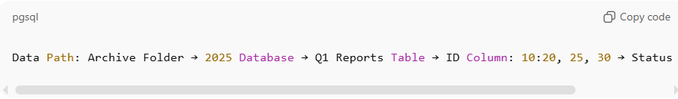
Data Path: Archive Folder → 2025 Database → Q1 Reports Table → ID Column: 10:20, 25, 30 → Status Column: Pending

✅ Explanation:
All IDs 10–20, 25, and 30 must have Status = Pending.

Column Grouping Reference
# Source: AI Source: Provided by: [Data Path: Persons Table -> ID Column: 1, Name_En Column: Motasem Essam] -> From: [ChatGPT] on [7/14/2025]
Purpose
Column Grouping allows multiple column–value sets (records) to be grouped under the same table reference, avoiding repetition and improving readability when referencing multiple rows from the same table.
This is especially useful when:
- Referencing multiple records from the same table
- Each record has its own set of column values
- You want a compact, structured representation
Syntax
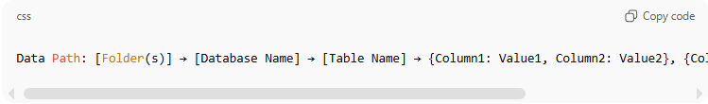
Data Path: [Folder(s)] → [Database Name] → [Table Name] → {Column1: Value1, Column2: Value2}, {Column1: Value3, Column2: Value4}
- { } (curly braces) define a single record group
- Each { } represents one logical row
- Multiple record groups are separated by , (comma)

Rules
1. Record Group Definition
- Each { } contains columns and values that belong to one record
- Columns inside a group follow the existing column rules
Example:
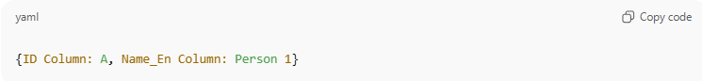
{ID Column: A, Name_En Column: Person 1}
2. Multiple Record Groups
- Multiple record groups can be listed under the same table
- Each group is evaluated independently
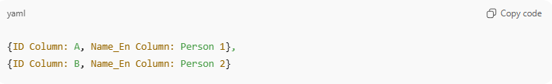
{ID Column: A, Name_En Column: Person 1},
{ID Column: B, Name_En Column: Person 2}
Logical meaning:
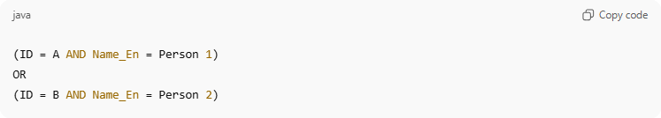
(ID = A AND Name_En = Person 1)
OR
(ID = B AND Name_En = Person 2)
3. Grouping vs Multiple Columns Rule
- Inside one group → columns use AND
- Between groups → groups use OR
4. Column Order Inside Groups
- Column order inside { } does NOT matter
- Filtering logic remains the same
5. Mixing with Ranges
- ID ranges can be used inside a group
- Other columns apply to all IDs in that group
Example:
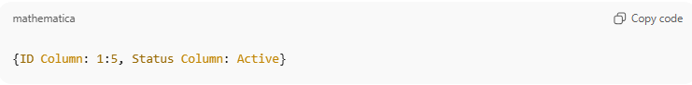
{ID Column: 1:5, Status Column: Active}
Comparison Example
❌ Without Grouping
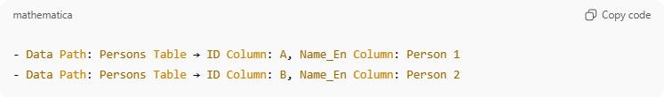
- Data Path: Persons Table → ID Column: A, Name_En Column: Person 1
- Data Path: Persons Table → ID Column: B, Name_En Column: Person 2

✅ With Column Grouping
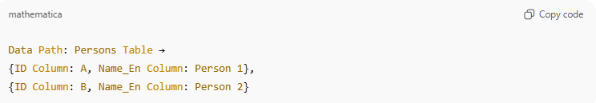
Data Path: Persons Table →
{ID Column: A, Name_En Column: Person 1},
{ID Column: B, Name_En Column: Person 2}

Example
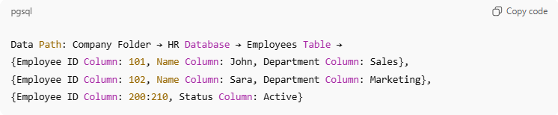
Data Path: Company Folder → HR Database → Employees Table →
{Employee ID Column: 101, Name Column: John, Department Column: Sales},
{Employee ID Column: 102, Name Column: Sara, Department Column: Marketing},
{Employee ID Column: 200:210, Status Column: Active}
Meaning:
- Match John in Sales
- OR Sara in Marketing
- OR all employees with IDs 200–210 who are Active

Formats:
# Source: AI Source: Provided by: [Data Path: Persons Table -> ID Column: 1, Name_En Column: Motasem Essam] -> From: [ChatGPT] on [7/14/2025]
1- Standard Format
2-Numbered Version Format

Standard Format
Single column
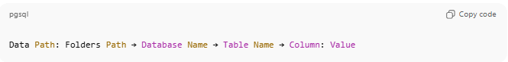
Data Path: Folders Path → Database Name → Table Name → Column: Value

Multiple Columns
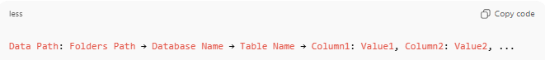
Data Path: Folders Path → Database Name → Table Name → Column1: Value1, Column2: Value2, ...

Numbered Version Format (Optional)
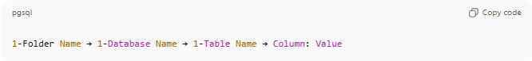
1-Folder Name → 1-Database Name → 1-Table Name → Column: Value

2- Data Path Attributes

1-Total Rows Count
# Source: AI Source: Provided by: [Data Path: Persons Table -> ID Column: 1, Name_En Column: Motasem Essam] -> From: [ChatGPT] on [7/14/2025]
Definition:
The Total Rows Count attribute allows explicitly recording the total number of rows referenced in a Data Path, either for specific data values or for an entire table, without listing all individual values. This is a metadata-only attribute and does not affect filtering or selection logic; it simply represents the resolved number of rows after all filters, ranges, or combinations are applied.

Syntax for data values Reference
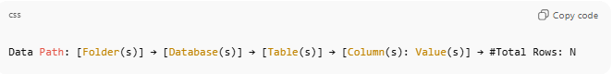
Data Path: [Folder(s)] → [Database(s)] → [Table(s)] → [Column(s): Value(s)] → #Total Rows: N
Syntax for Entire Table Reference
• You can also calculate total rows for a table without specifying columns or values:
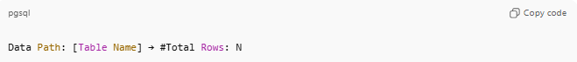
Data Path: [Table Name] → #Total Rows: N
Placement Rules
• #Total Rows is optional
• Must appear after a Data Value Reference or Table Reference
• Does not affect filtering — it is metadata only
• Represents the final resolved count after all filters, ranges, and combinations are applied

Examples
Example 1: Total rows for a single ID/value
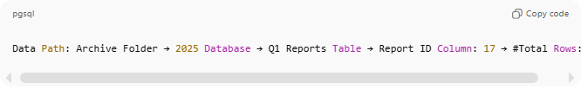
Data Path: Archive Folder → 2025 Database → Q1 Reports Table → Report ID Column: 17 → #Total Rows: 1
Example 2: Total rows for a range of values
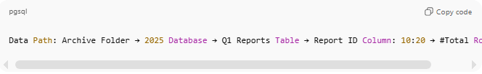
Data Path: Archive Folder → 2025 Database → Q1 Reports Table → Report ID Column: 10:20 → #Total Rows: 10
Example 3: Total rows with mixed ranges and values
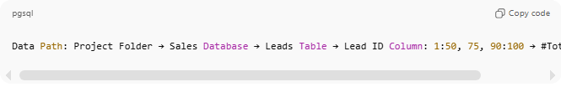
Data Path: Project Folder → Sales Database → Leads Table → Lead ID Column: 1:50, 75, 90:100 → #Total Rows: 61
Example 4: Total rows after multiple column filters
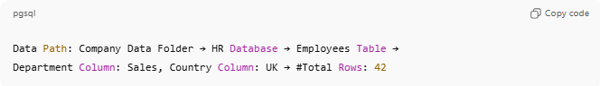
Data Path: Company Data Folder → HR Database → Employees Table →
Department Column: Sales, Country Column: UK → #Total Rows: 42
Example 5: Total rows across multiple databases and tables
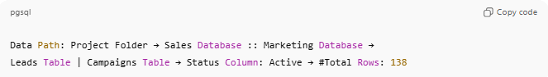
Data Path: Project Folder → Sales Database :: Marketing Database →
Leads Table | Campaigns Table → Status Column: Active → #Total Rows: 138
Example 6: Total rows for an entire table
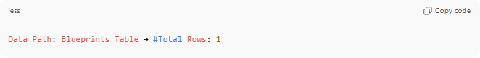
Data Path: Blueprints Table → #Total Rows: 1

2-Includes
# Source: AI Source: Provided by: [Data Path: Persons Table -> ID Column: 1, Name_En Column: Motasem Essam] -> From: [ChatGPT] on [7/14/2025]
Definition:
The #Includes attribute provides a categorical breakdown of the rows referenced in a Data Path. It describes how the total rows are composed by type, category, or any sub-classification, without listing each individual row.
It is metadata only and does not affect filtering or selection logic.
#Includes can be added after #Total Rows, directly after data values in a column, or after an entire table reference to provide additional context about the composition of the referenced rows.

Syntax
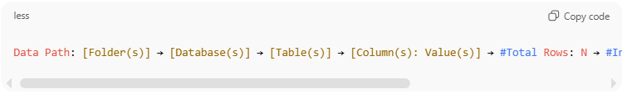
Data Path: [Folder(s)] → [Database(s)] → [Table(s)] → [Column(s): Value(s)] → #Total Rows: N → #Includes: Category1 Count1, Category2 Count2, ...
- Category1, Category2, … → types or classifications of rows (e.g., Game, Article, Draft).
- Count1, Count2, … → number of rows in each category.
- Categories are separated by commas.
- #Includes can also appear without #Total Rows, directly after data values or a table reference.

Placement Rules
- Can appear:
  - After #Total Rows (common usage).
  - Directly after data values in a column (e.g., specific IDs or ranges).
  - Directly after an entire table reference.
- Metadata only: Does not affect filtering or selection.
- Can be applied to single tables, multiple tables, or data values.

Examples
Example 1: After #Total Rows (standard)
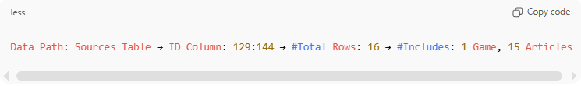
Data Path: Sources Table → ID Column: 129:144 → #Total Rows: 16 → #Includes: 1 Game, 15 Articles
Meaning: Total rows: 16 → 1 Game and 15 Articles
Example 2: Directly after entire table (without #Total Rows)
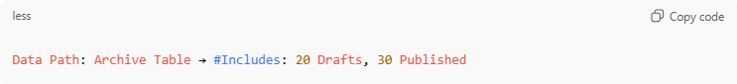
Data Path: Archive Table → #Includes: 20 Drafts, 30 Published
Meaning: Entire table has 50 rows categorized as 20 Drafts and 30 Published
Example 3: Directly after data values in a column (without #Total Rows)
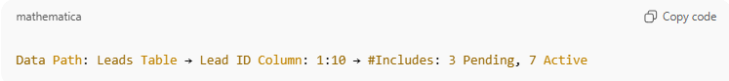
Data Path: Leads Table → Lead ID Column: 1:10 → #Includes: 3 Pending, 7 Active
Meaning: 10 rows total, 3 Pending, 7 Active
Example 4: Multiple tables with #Total Rows and #Includes
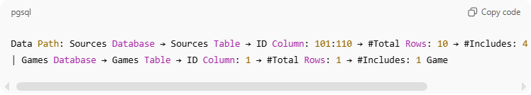
Data Path: Sources Database → Sources Table → ID Column: 101:110 → #Total Rows: 10 → #Includes: 4 Videos, 6 Articles
| Games Database → Games Table → ID Column: 1 → #Total Rows: 1 → #Includes: 1 Game
Meaning:
- Sources Table: 10 rows → 4 Videos, 6 Articles
- Games Table: 1 row → 1 Game

Notes
- Provides a categorical breakdown for reporting, auditing, or summarizing datasets.
- Can be combined with #Total Rows for precise counts or used alone as descriptive metadata.
- Works with ranges, multiple columns, multiple tables

3-Description
# Source: AI Source: Provided by: [Data Path: Persons Table -> ID Column: 1, Name_En Column: Motasem Essam] -> From: [ChatGPT] on [7/14/2025]
Definition:
The Description attribute provides a textual note or explanation for a Data Path, table, column, or specific data value. It is metadata only and does not affect filtering, selection, or data retrieval.
This attribute is used to add context, comments, or clarifications about the data being referenced, making the Data Path more informative and easier to understand.

Syntax
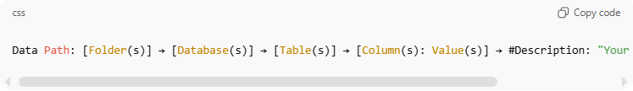
Data Path: [Folder(s)] → [Database(s)] → [Table(s)] → [Column(s): Value(s)] → #Description: "Your descriptive text here"
- The description is enclosed in quotes.
- Can include any text, such as explanations, notes, or references.
- Can be used with other attributes like #Total Rows or #Includes.

Placement Rules
- Placed after the data reference or other attributes (e.g., after #Total Rows or #Includes).
- Metadata only: Does not affect filtering or selection.
- Can be applied to:
  - A table
  - Specific columns or column values
  - Entire database references

Examples
Example 1: Description for a table
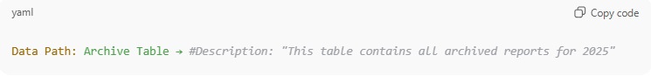
Data Path: Archive Table → #Description: "This table contains all archived reports for 2025"
Example 2: Description for specific column values
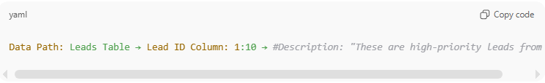
Data Path: Leads Table → Lead ID Column: 1:10 → #Description: "These are high-priority leads from Q1"
Example 3: Combined with #Total Rows and #Includes
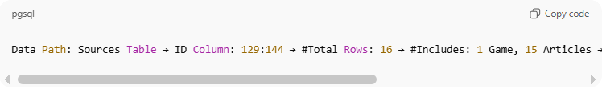
Data Path: Sources Table → ID Column: 129:144 → #Total Rows: 16 → #Includes: 1 Game, 15 Articles → #Description: "Content sources collected in July 2025"

Notes
- The Description attribute is informational.
- Enhances readability and context for datasets, especially for reporting or documentation.
- Can coexist with other Data Path attributes like #Total Rows and #Includes.

2-Data Size Suffix

Knowledge Base

1-Data Size Suffix
# Source: AI Source: Provided by: [Data Path: Persons Table -> ID Column: 1, Name_En Column: Motasem Essam] -> From: [ChatGPT] on [7/14/2025]
The Data Size Suffix adds a size indicator (number of rows, columns, or both) at the end of a data path, inside square brackets.
🔹 Purpose
- To make database documentation clearer and more standardized.
- To instantly show table size (data volume and structure).
- To help analysts, developers, or system tools compare tables quickly.

Rules and Guidelines

1-Data Size Suffix
# Source: AI Source: Provided by: [Data Path: Persons Table -> ID Column: 1, Name_En Column: Motasem Essam] -> From: [ChatGPT] on [7/14/2025]
Rule Definition:
Add the total number of rows, columns, or both in the table as a suffix at the end of the data path, enclosed in square brackets. Use clear labels:
- Rows: for row count
- Columns: for column count
- Rows x Columns: for both
🔹 Syntax
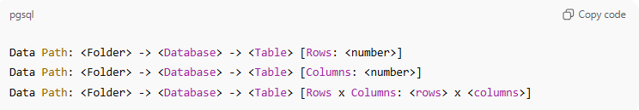
Data Path: <Folder> -> <Database> -> <Table> [Rows: <number>]
Data Path: <Folder> -> <Database> -> <Table> [Columns: <number>]
Data Path: <Folder> -> <Database> -> <Table> [Rows x Columns: <rows> x <columns>]

🔹 Examples
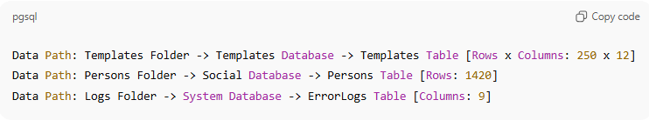
Data Path: Templates Folder -> Templates Database -> Templates Table [Rows x Columns: 250 x 12]
Data Path: Persons Folder -> Social Database -> Persons Table [Rows: 1420]
Data Path: Logs Folder -> System Database -> ErrorLogs Table [Columns: 9]

Usage Notes:
- Always place the size suffix immediately after the table name.
- The numbers represent the current structural and data size of the table.
- Use the Rows x Columns form when both metrics are available or relevant.
- Keep it updated as the table grows or changes structure.
- This rule applies only at the table level, not at folder or database level.

3-Data Collections

Knowledge Base

1-what is Data Collections
# Source: AI Source: Provided by: [Data Path: Persons Table -> ID Column: 1, Name_En Column: Motasem Essam] -> From: [ChatGPT] on [7/14/2025]
Definition:
A Data Collection is a structured grouping of one or more Data Paths, optionally including their Data Size Suffix. It represents all relevant tables or datasets under a specific folder or logical grouping, combining both Data Path and Data Size Suffix rules.
Purpose:
- To organize multiple datasets under a single folder or logical unit.
- To summarize all relevant tables with their size, location, and structure.
- To improve clarity for documentation, analysis, and system mapping.
Key Points:
- Combines Two Rules:
  - Data Path: exact location hierarchy.
  - Data Size Suffix: table/column dimensions.
- Organized by Folder or Project:
  - Each collection groups multiple datasets for clarity.
- Flexible & Scalable:
  - Add as many folders or tables as needed.
  - Optional numbering allows easier referencing.

Rules and Guidelines

1-Data Collections Structure
# Source: AI Source: Provided by: [Data Path: Persons Table -> ID Column: 1, Name_En Column: Motasem Essam] -> From: [ChatGPT] on [7/14/2025]
Top Summary (Displayed at the Start)
This will appear at the top of your document for quick reference: Total Tables, Total Rows and Total Columns
Example
Total Tables: 80
Total Rows: 4342
Total Columns: 1181

Format
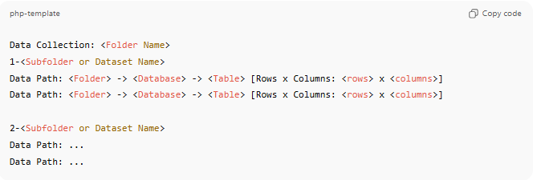
Data Collection: <Folder Name>
1-<Subfolder or Dataset Name>
Data Path: <Folder> -> <Database> -> <Table> [Rows x Columns: <rows> x <columns>]
Data Path: <Folder> -> <Database> -> <Table> [Rows x Columns: <rows> x <columns>]

2-<Subfolder or Dataset Name>
Data Path: ...
Data Path: ...

  - Numbering (1, 2, 3…) is optional, but recommended for ordered references.
  - Each Data Path follows the Data Path rule and may include the Data Size Suffix.
  - Each collection can include multiple folders or datasets

Example
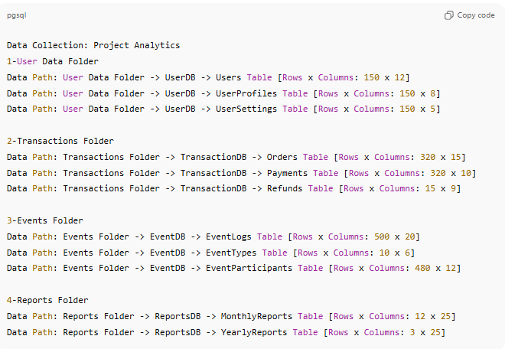
Data Collection: Project Analytics
1-User Data Folder
Data Path: User Data Folder -> UserDB -> Users Table [Rows x Columns: 150 x 12]
Data Path: User Data Folder -> UserDB -> UserProfiles Table [Rows x Columns: 150 x 8]
Data Path: User Data Folder -> UserDB -> UserSettings Table [Rows x Columns: 150 x 5]

2-Transactions Folder
Data Path: Transactions Folder -> TransactionDB -> Orders Table [Rows x Columns: 320 x 15]
Data Path: Transactions Folder -> TransactionDB -> Payments Table [Rows x Columns: 320 x 10]
Data Path: Transactions Folder -> TransactionDB -> Refunds Table [Rows x Columns: 15 x 9]

3-Events Folder
Data Path: Events Folder -> EventDB -> EventLogs Table [Rows x Columns: 500 x 20]
Data Path: Events Folder -> EventDB -> EventTypes Table [Rows x Columns: 10 x 6]
Data Path: Events Folder -> EventDB -> EventParticipants Table [Rows x Columns: 480 x 12]

4-Reports Folder
Data Path: Reports Folder -> ReportsDB -> MonthlyReports Table [Rows x Columns: 12 x 25]
Data Path: Reports Folder -> ReportsDB -> YearlyReports Table [Rows x Columns: 3 x 25]

4-Data Cell

Knowledge Base

1-what is Data Cell
# Source: AI Source: Provided by: [Data Path: Persons Table -> ID Column: 1, Name_En Column: Motasem Essam] -> From: [ChatGPT] on [7/14/2025]
A Data Cell usually means the smallest single unit of stored data — like the intersection of a row and a column in a table.
Think of it like this:
- Table → whole sheet (like in Excel or a database table).
- Row (Record) → one entry (e.g., Customer #5).
- Column (Field) → a property (e.g., Email).
- Cell → the exact value at the intersection of a row and column (e.g., Customer #5’s Email = test@email.com).
📌 Example:
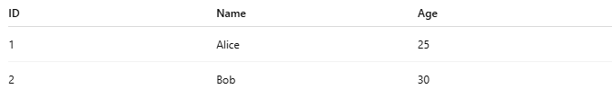
ID | Name | Age
1 | Alice | 25
2 | Bob | 30
- The whole table = Dataset
- Row 1 = Record (ID=1, Name=Alice, Age=25)
- Column "Age" = Field
- The value 25 = Data Cell

Rules and Guidelines

1-Cell Entry Fill

1. Filling a Cell with Single Value
# Source: AI Source: Provided by: [Data Path: Persons Table -> ID Column: 1, Name_En Column: Motasem Essam] -> From: [ChatGPT] on [7/14/2025]
  - When entering a single value in a cell, write it directly as plain text.
  - Example:
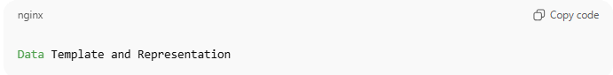
Data Template and Representation

2. Filling a Cell with Multiple Values
# Source: AI Source: Provided by: [Data Path: Persons Table -> ID Column: 1, Name_En Column: Motasem Essam] -> From: [ChatGPT] on [7/14/2025]
  - When entering multiple values in a single cell, use a list format, starting each value with a hyphen -.
  - If the field supports the ability to hold multiple items, values should be written in a list format, with each item starting with a hyphen -.
  - If only one item exists, list format is still optional, but supported for future expansion.
  - Example:
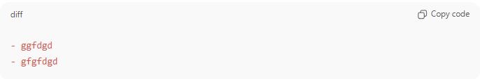
  - - ggfdgd
  - – gfgfdgd

3. Sequential Content with Numbered Items
# Source: AI Source: Provided by: [Data Path: Persons Table -> ID Column: 1, Name_En Column: Motasem Essam] -> From: [ChatGPT] on [7/14/2025]
- Sequential Numbering
  - Each content unit must begin with a sequential number (1, 2, 3…) representing its order in the structure.
  - This is the record index, not the hierarchy itself.
- Hierarchical Label
  - After the index, include a hierarchical label such as 0-Introduction, 1-Fundamentals, 2-Lifecycle, etc.
  - This label reflects the logical order of chapters, sections, or modules.
- Optional Metadata (Duration or Attributes)
  - Content items may include metadata after the label, separated by an en dash –.
  - Example: 1-Fundamentals of Testing – 180 minutes.
  - Metadata can be time (e.g., 180 minutes), length (e.g., 25 pages), or any other measure.
- Appendices
  - Appendices are labeled after the main sequence using letters or descriptive names.
  - Example: Appendix A – Learning Objectives, Appendix B – Traceability Matrix.
- References & Index
  - References and Index are reserved items that may always be included at the end of the structure.
  - References provide sources; Index provides navigation.
- Flexibility Across Domains
  - This structure can represent:
    - Books → chapters, appendices, index.
    - Courses → modules, sessions with durations, references.
    - Documents → sections, appendices, release notes.
    - Systems → structured records, knowledge bases.

Example (Generalized):
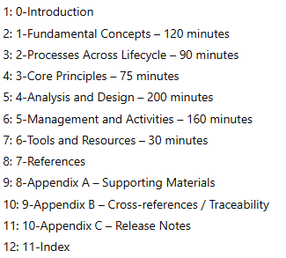
1: 0-Introduction
2: 1-Fundamental Concepts – 120 minutes
3: 2-Processes Across Lifecycle – 90 minutes
4: 3-Core Principles – 75 minutes
5: 4-Analysis and Design – 200 minutes
6: 5-Management and Activities – 160 minutes
7: 6-Tools and Resources – 30 minutes
8: 7-References
9: 8-Appendix A – Supporting Materials
10: 9-Appendix B – Cross-references / Traceability
11: 10-Appendix C – Release Notes
12: 11-Index

4. Numbered Outlines for Any Structured Content
# Source: AI Source: Provided by: [Data Path: Persons Table -> ID Column: 1, Name_En Column: Motasem Essam] -> From: [ChatGPT] on [7/14/2025]
- Numbered outlines can be used to organize any structured information.
- Decimal numbering reflects hierarchy and can go to any depth.
- Add three spaces before each child heading to visually separate it from its parent.
- Sub-items can contain extended data, examples, or references.
- Hyphens at the start of lines are optional; main numbering indicates structure.
- Example with Templates Table:
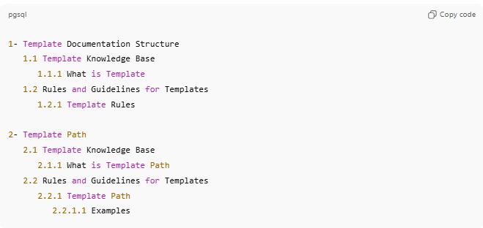
1- Template Documentation Structure
1.1 Template Knowledge Base
1.1.1 What is Template
1.2 Rules and Guidelines for Templates
1.2.1 Template Rules

2- Template Path
2.1 Template Knowledge Base
2.1.1 What is Template Path
2.2 Rules and Guidelines for Templates
2.2.1 Template Path
2.2.1.1 Examples
Notes:
- Decimal numbering reflects the hierarchy clearly.
- Each section or sub-section can include notes, examples, or extended items.
- Useful for documenting templates, tables, procedures, or any structured content.

5. Nested Lists in Data Template
# Source: AI Source: Provided by: [Data Path: Persons Table -> ID Column: 1, Name_En Column: Motasem Essam] -> From: [ChatGPT] on [7/14/2025]
    - Markers by Level
- Level 1 (parent): - (hyphen)
- Level 2 (child): * (asterisk)
- Level 3 (grandchild): . (dot)
    - Indentation
Each nested level must have 3 spaces before its marker.
    - Optional Empty Line Rule
- You may insert an empty line only between two Level 1 items (hyphen -).
- No empty lines between children (*) or grandchildren (.), unless you want a visual separation for readability in very long lists.

Example
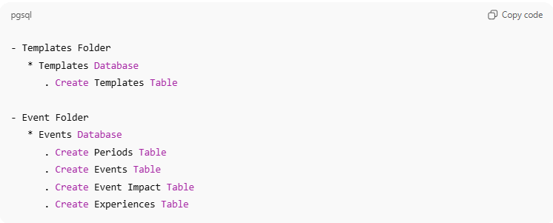
- Templates Folder
* Templates Database
. Create Templates Table

- Event Folder
* Events Database
. Create Periods Table
. Create Events Table
. Create Event Impact Table
. Create Experiences Table
✅ This way, your rule is generalized but still captures the sequential structure, optional durations, appendices, references, and index.
Do you want me to also turn this into a database template schema (with fields like IndexNumber, Label, Metadata, Type, etc.) so you can store these entries in your system?

6. Notes or Source Format
# Source: AI Source: Provided by: [Data Path: Persons Table -> ID Column: 1, Name_En Column: Motasem Essam] -> From: [ChatGPT] on [7/14/2025]
When adding a note, explanation, or the source of information related to a value, field, or topic, start it with # followed by the description.
This can include:
    - Clarifications about the data
    - References to the source of the information (e.g., book, article, website, AI output)
    - Any additional context that helps understand or verify the value

I. General note
# Source: AI Source: Provided by: [Data Path: Persons Table -> ID Column: 1, Name_En Column: Motasem Essam] -> From: [ChatGPT] on [7/14/2025]
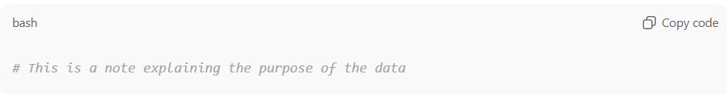
# This is a note explaining the purpose of the data

II. General Source Rule (format):
# Source: AI Source: Provided by: [Data Path: Persons Table -> ID Column: 1, Name_En Column: Motasem Essam] -> From: [ChatGPT] on [7/14/2025]
To indicate a detailed source, Always write sources using the structure
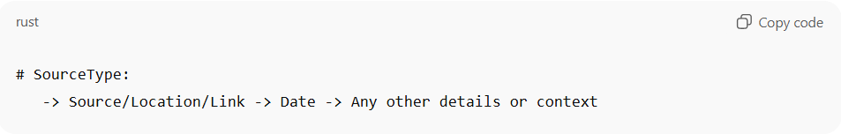
# SourceType:
-> Source/Location/Link -> Date -> Any other details or context
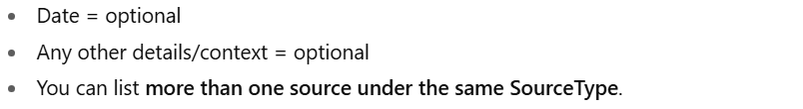
  - Date = optional
  - Any other details/context = optional
  - You can list more than one source under the same SourceType.

III. ✅ Source Types & Formats

I. Web link
# Source: AI Source: Provided by: [Data Path: Persons Table -> ID Column: 1, Name_En Column: Motasem Essam] -> From: [ChatGPT] on [7/14/2025]
Format:
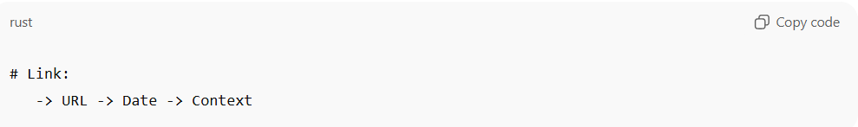
# Link:
-> URL -> Date -> Context
Example (single): 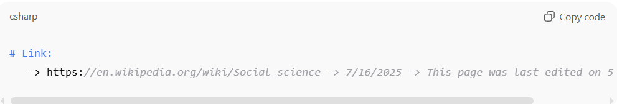
Example (multiple):
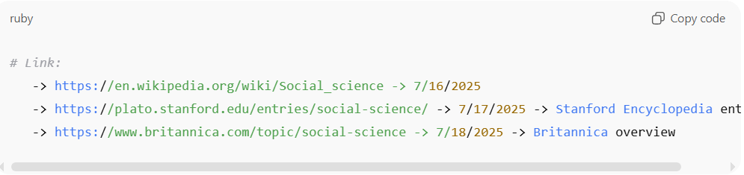
# Link:
-> https://en.wikipedia.org/wiki/Social_science -> 7/16/2025
-> https://plato.stanford.edu/entries/social-science/ -> 7/17/2025 -> Stanford Encyclopedia entry
-> https://www.britannica.com/topic/social-science -> 7/18/2025 -> Britannica overview

II. 💾 Cloud/Physical storage
# Source: AI Source: Provided by: [Data Path: Persons Table -> ID Column: 1, Name_En Column: Motasem Essam] -> From: [ChatGPT] on [7/14/2025]
Format:
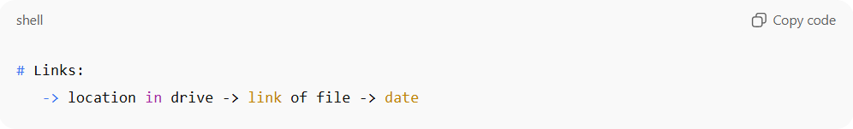
# Links:
-> location in drive -> link of file -> date
Example (single):
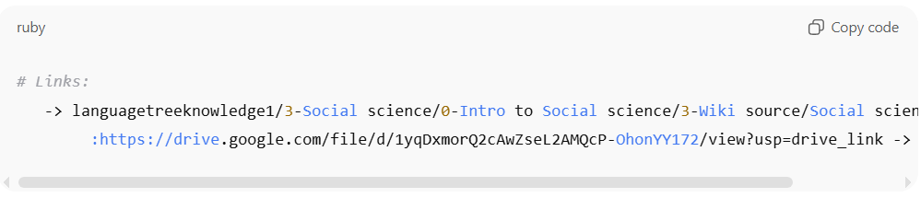
# Links:
-> languagetreeknowledge1/3-Social science/0-Intro to Social science/3-Wiki source/Social science.pdf
:https://drive.google.com/file/d/1yqDxmorQ2cAwZseL2AMQcP-OhonYY172/view?usp=drive_link -> 7/16/2025

Example (multiple):
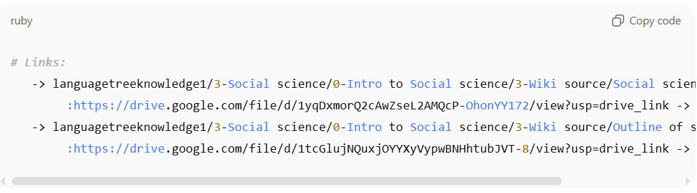
# Links:
-> languagetreeknowledge1/3-Social science/0-Intro to Social science/3-Wiki source/Social science.pdf
:https://drive.google.com/file/d/1yqDxmorQ2cAwZseL2AMQcP-OhonYY172/view?usp=drive_link -> 7/16/2025
-> languagetreeknowledge1/3-Social science/0-Intro to Social science/3-Wiki source/Outline of social science.pdf
:https://drive.google.com/file/d/1tcGlujNQuxjOYYXyVypwBNHhtubJVT-8/view?usp=drive_link -> 7/16/2025

III. 🎥 Video
# Source: AI Source: Provided by: [Data Path: Persons Table -> ID Column: 1, Name_En Column: Motasem Essam] -> From: [ChatGPT] on [7/14/2025]
Format:
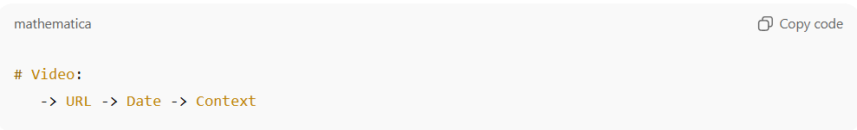
# Video:
-> URL -> Date -> Context

Example:
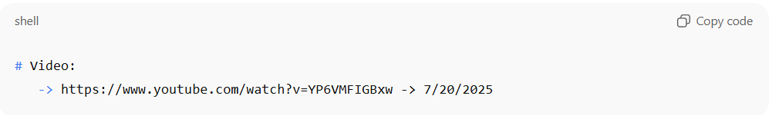
# Video:
-> https://www.youtube.com/watch?v=YP6VMFIGBxw -> 7/20/2025

IV. 🤖 AI output
# Source: AI Source: Provided by: [Data Path: Persons Table -> ID Column: 1, Name_En Column: Motasem Essam] -> From: [ChatGPT] on [7/14/2025]
Format:
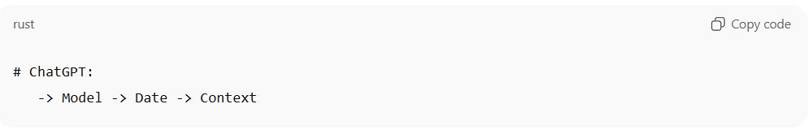
# ChatGPT:
-> Model -> Date -> Context
Example:
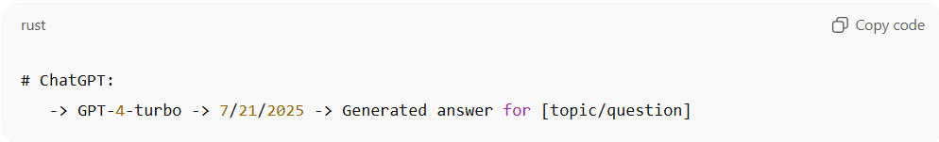
# ChatGPT:
-> GPT-4-turbo -> 7/21/2025 -> Generated answer for [topic/question]

V. 📚 Book
# Source: AI Source: Provided by: [Data Path: Persons Table -> ID Column: 1, Name_En Column: Motasem Essam] -> From: [ChatGPT] on [7/14/2025]
Format:
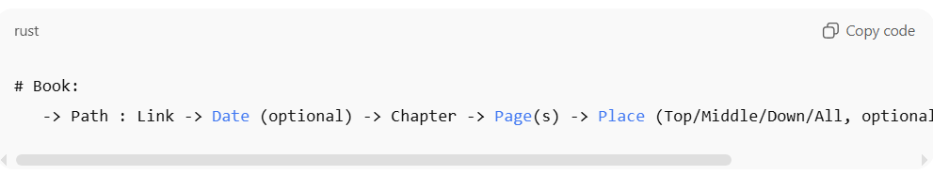
# Book:
-> Path : Link -> Date (optional) -> Chapter -> Page(s) -> Place (Top/Middle/Down/All, optional) -> Context (optional)

- Path = file path in your storage system (physical or digital)
- Link = optional cloud/online link
- Date = optional
- Chapter = chapter number or title
- Page(s) = single page (e.g., 45) or page range (e.g., 45:50)
- Place(s) = Top, Middle, Down, multiple places on the same page (e.g., Top, Middle), All for the whole page, or omitted
- Context = optional note or description

Example (single page, multiple places on same page): 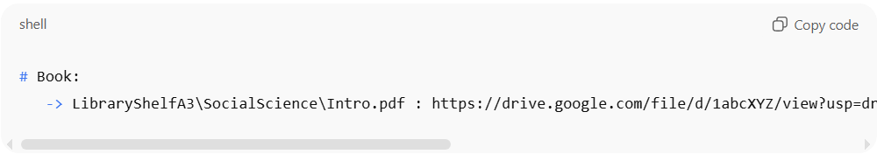
# Book:
-> LibraryShelfA3\SocialScience\Intro.pdf : https://drive.google.com/file/d/1abcXYZ/view?usp=drive_link -> 7/16/2025 -> Chapter 2 -> Page 45 -> Top, Middle -> Definition and explanation

Example (single page, place = All):
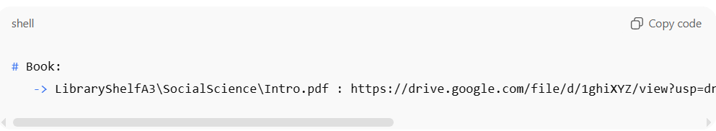
# Book:
-> LibraryShelfA3\SocialScience\Intro.pdf : https://drive.google.com/file/d/1ghiXYZ/view?usp=drive_link -> Chapter 2 -> Page 45 -> All -> Full definition of Social Science

Example (page range, place omitted):
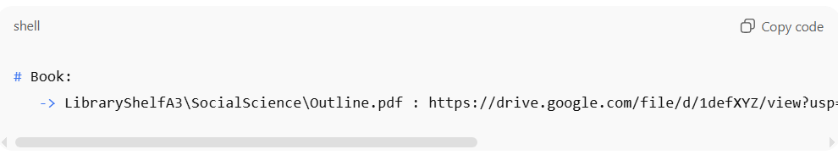
# Book:
-> LibraryShelfA3\SocialScience\Outline.pdf : https://drive.google.com/file/d/1defXYZ/view?usp=drive_link -> Chapter 1 -> Pages 12:15 -> Summary of multiple sections

Example (multiple entries):
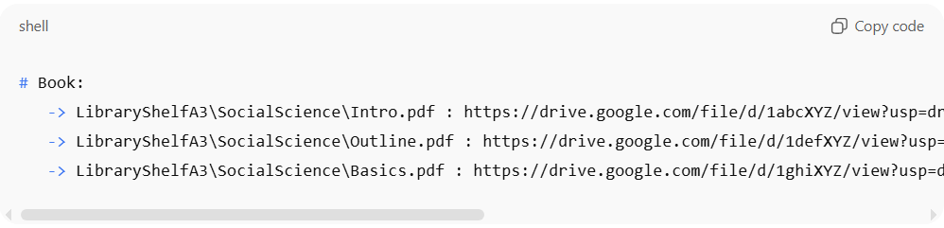
# Book:
-> LibraryShelfA3\SocialScience\Intro.pdf : https://drive.google.com/file/d/1abcXYZ/view?usp=drive_link -> 7/16/2025 -> Chapter 2 -> Page 45 -> Top, Middle -> Definition and explanation
-> LibraryShelfA3\SocialScience\Outline.pdf : https://drive.google.com/file/d/1defXYZ/view?usp=drive_link -> Chapter 1 -> Pages 12:15 -> Summary of multiple sections
-> LibraryShelfA3\SocialScience\Basics.pdf : https://drive.google.com/file/d/1ghiXYZ/view?usp=drive_link -> Chapter 3 -> Page 22 -> All -> Overview of topic

VI. 🗄 Database Record
# Source: AI Source: Provided by: [Data Path: Persons Table -> ID Column: 1, Name_En Column: Motasem Essam] -> From: [ChatGPT] on [7/14/2025]
Format:
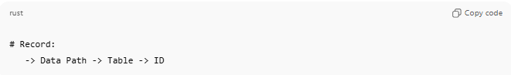
# Record:
-> Data Path -> Table -> ID

Example:
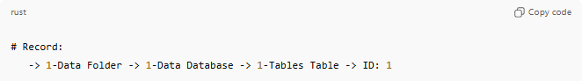
# Record:
-> 1-Data Folder -> 1-Data Database -> 1-Tables Table -> ID: 1

7. Heading Format
# Source: AI Source: Provided by: [Data Path: Persons Table -> ID Column: 1, Name_En Column: Motasem Essam] -> From: [ChatGPT] on [7/14/2025]
The Sectioned Information Entry Standard defines how to record information inside a single cell, document, or text block using a clear hierarchical structure.
- Uses headings (#) and subheadings (##, ###) to organize content.
  - # = Main heading (big section, like a chapter title)
  - ## = Sub-heading (section inside the main heading)
  - ### = Smaller heading (sub-division inside a sub-heading)

Rules
- Headings define structure
  - Use #, ##, ### to create a clear hierarchy.
- Every heading may have content
  - A heading is not just a label. It can include direct text content under it.
  - Example:
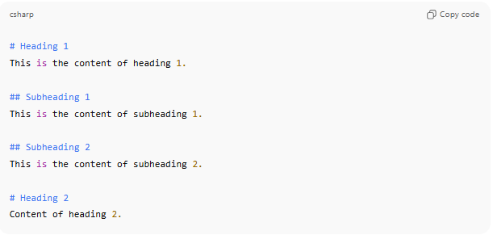
# Heading 1
This is the content of heading 1.

## Subheading 1
This is the content of subheading 1.

## Subheading 2
This is the content of subheading 2.

# Heading 2
Content of heading 2.

- Parent headings without content are allowed (optional)
  - A parent heading can act only as a container for child headings without having its own content.
  - Example:
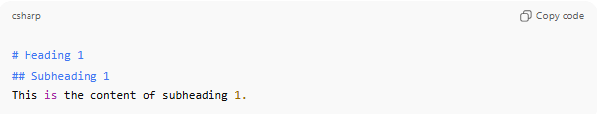
# Heading 1
## Subheading 1
This is the content of subheading 1.
- Content can take any form
  - Content under a heading can be:
    - Plain text
    - Lists (bulleted or numbered)
    - Tables
    - Code blocks, examples, or mixed
  - Example:
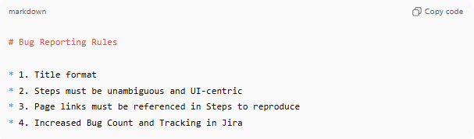
# Bug Reporting Rules

* 1. Title format
* 2. Steps must be unambiguous and UI-centric
* 3. Page links must be referenced in Steps to reproduce
* 4. Increased Bug Count and Tracking in Jira

Example
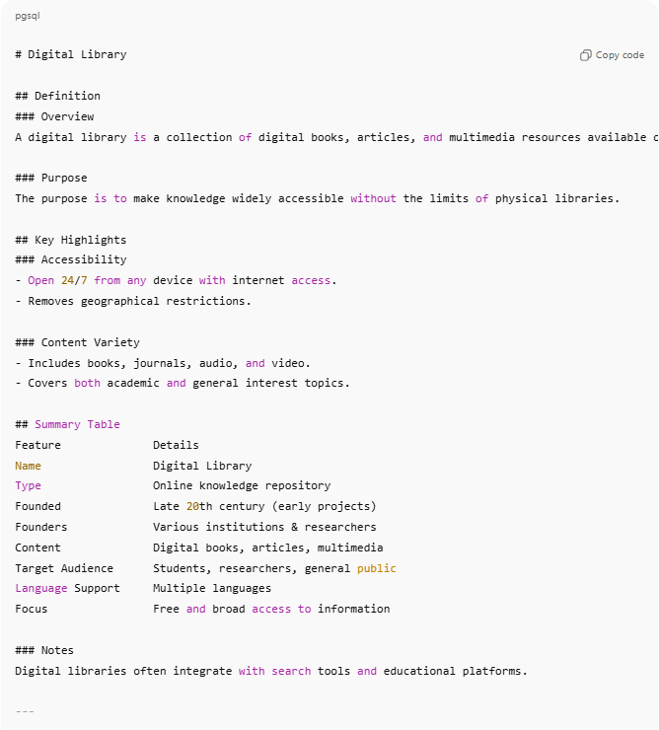
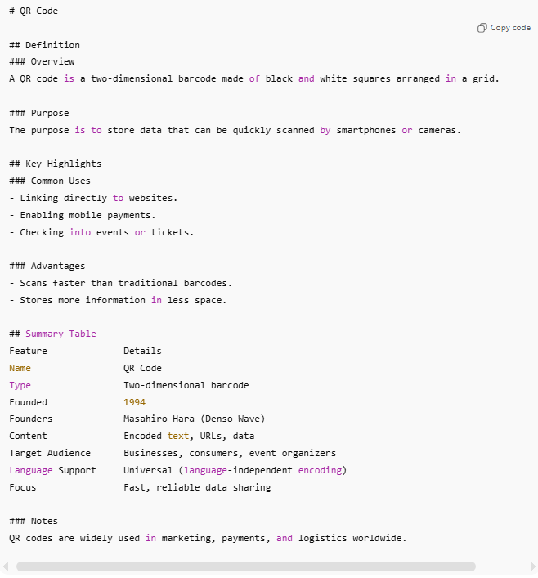
# Digital Library

## Definition
### Overview
A digital library is a collection of digital books, articles, and multimedia resources available online.

### Purpose
The purpose is to make knowledge widely accessible without the limits of physical libraries.

## Key Highlights
### Accessibility
- Open 24/7 from any device with internet access.
- Removes geographical restrictions.

### Content Variety
- Includes books, journals, audio, and video.
- Covers both academic and general interest topics.

## Summary Table
Feature Details
Name Digital Library
Type Online knowledge repository
Founded Late 20th century (early projects)
Founders Various institutions & researchers
Content Digital books, articles, multimedia
Target Audience Students, researchers, general public
Language Support Multiple languages
Focus Free and broad access to information

### Notes
Digital libraries often integrate with search tools and educational platforms.

---

# QR Code

## Definition
### Overview
A QR code is a two-dimensional barcode made of black and white squares arranged in a grid.

### Purpose
The purpose is to store data that can be quickly scanned by smartphones or cameras.

## Key Highlights
### Common Uses
- Linking directly to websites.
- Enabling mobile payments.
- Checking into events or tickets.

### Advantages
- Scans faster than traditional barcodes.
- Stores more information in less space.

## Summary Table
Feature Details
Name QR Code
Type Two-dimensional barcode
Founded 1994
Founders Masahiro Hara (Denso Wave)
Content Encoded text, URLs, data
Target Audience Businesses, consumers, event organizers
Language Support Universal (language-independent encoding)
Focus Fast, reliable data sharing

### Notes
QR codes are widely used in marketing, payments, and logistics worldwide.

8. Math Format
# Source: AI Source: Provided by: [Data Path: Persons Table -> ID Column: 1, Name_En Column: Motasem Essam] -> From: [ChatGPT] on [7/14/2025]

I. Marker Rule
# Source: AI Source: Provided by: [Data Path: Persons Table -> ID Column: 1, Name_En Column: Motasem Essam] -> From: [ChatGPT] on [7/14/2025]
- All math lines must start with §.
- Applies to:
  - Basic arithmetic
  - Equations
  - Functions
  - Roots and powers
  - Sequences, totals, and nested calculations

II. Operators & Symbols
# Source: AI Source: Provided by: [Data Path: Persons Table -> ID Column: 1, Name_En Column: Motasem Essam] -> From: [ChatGPT] on [7/14/2025]
Use these standard symbols in math entries:
- + → Addition
- − → Subtraction
- × → Multiplication
- ÷ → Division
- = → Equals / result
- () → Parentheses for grouping
- ^ → Power / exponent
- √ → Square root
- root(x, n) → n-th root of x, returns y such that yⁿ = x
- |x| → Absolute value
- → → Implies / mapping
- Functions: sin(), cos(), tan(), log(), ln(), exp(), f(x), etc.
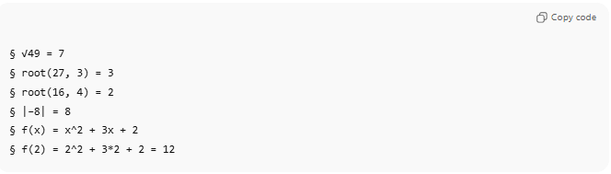
§ √49 = 7
§ root(27, 3) = 3
§ root(16, 4) = 2
§ |−8| = 8
§ f(x) = x^2 + 3x + 2
§ f(2) = 2^2 + 3*2 + 2 = 12

III. Equation Blocks (Multi-step / Solving Unknowns)
# Source: AI Source: Provided by: [Data Path: Persons Table -> ID Column: 1, Name_En Column: Motasem Essam] -> From: [ChatGPT] on [7/14/2025]
- Start of equation: §⟦ followed by optional description
- End of equation: §⟧
- Steps inside the block:
  - § → main step (e.g., rewrite equation, isolate variable)
  - §* → sub-step (calculate a sub-expression)
  - §. → sub-sub-step (rare, deeper sub-calculation)
Example – Linear Equation
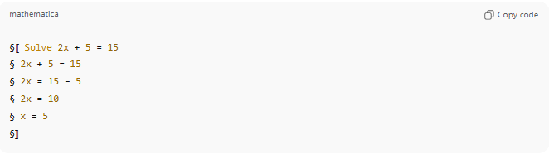
§⟦: Solve 2x + 5 = 15
§ 2x + 5 = 15
§ 2x = 15 − 5
§ 2x = 10
§ x = 5
§⟧

Example – Quadratic Equation
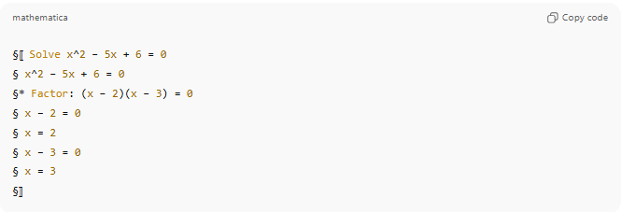
§⟦ Solve x^2 − 5x + 6 = 0
§ x^2 − 5x + 6 = 0
§* Factor: (x − 2)(x − 3) = 0
§ x − 2 = 0
§ x = 2
§ x − 3 = 0
§ x = 3
§⟧

Example – Quadratic using the quadratic formula
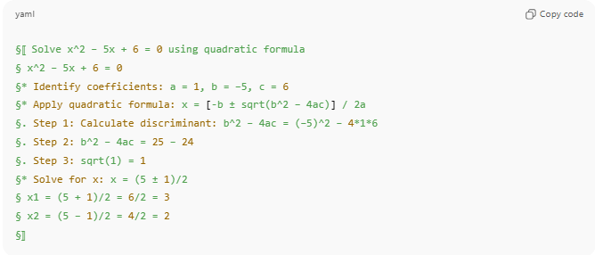
§⟦ Solve x^2 − 5x + 6 = 0 using quadratic formula
§ x^2 − 5x + 6 = 0
§* Identify coefficients: a = 1, b = −5, c = 6
§* Apply quadratic formula: x = [-b ± sqrt(b^2 − 4ac)] / 2a
§. Step 1: Calculate discriminant: b^2 − 4ac = (−5)^2 − 4*1*6
§. Step 2: b^2 − 4ac = 25 − 24
§. Step 3: sqrt(1) = 1
§* Solve for x: x = (5 ± 1)/2
§ x1 = (5 + 1)/2 = 6/2 = 3
§ x2 = (5 − 1)/2 = 4/2 = 2
§⟧

Example – Function Equation
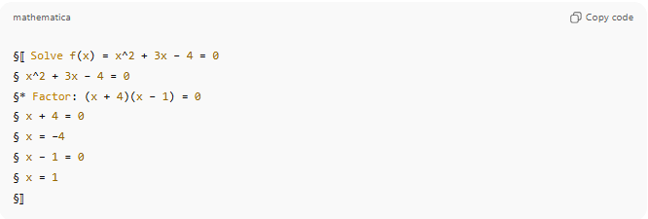
§⟦ Solve f(x) = x^2 + 3x − 4 = 0
§ x^2 + 3x − 4 = 0
§* Factor: (x + 4)(x − 1) = 0
§ x + 4 = 0
§ x = −4
§ x − 1 = 0
§ x = 1
§⟧

IV. Units / Labels
# Source: AI Source: Provided by: [Data Path: Persons Table -> ID Column: 1, Name_En Column: Motasem Essam] -> From: [ChatGPT] on [7/14/2025]
- Add units after the result if needed.
- Optional labels: (Subtotal), (Total), (Step 1)
- Example:

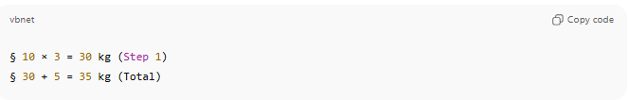
§ 10 × 3 = 30 kg (Step 1)
§ 30 + 5 = 35 kg (Total)

V. Hierarchical / Nested Currency Entries
# Source: AI Source: Provided by: [Data Path: Persons Table -> ID Column: 1, Name_En Column: Motasem Essam] -> From: [ChatGPT] on [7/14/2025]
- Heading # specifies the currency
- Each calculation line starts with §
- Totals are clearly labeled with § Total = …
- Can be extended for any currency, multi-step calculations, or nested sub-steps using §* or §.
- Example:
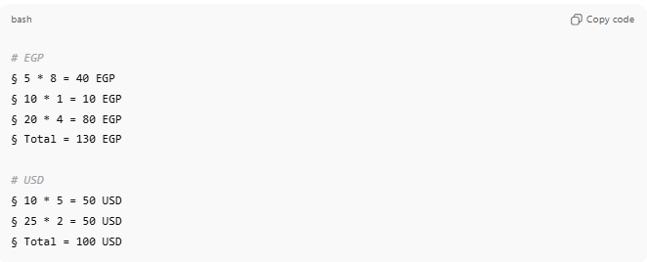
# EGP
§ 5 * 8 = 40 EGP
§ 10 * 1 = 10 EGP
§ 20 * 4 = 80 EGP
§ Total = 130 EGP

# USD
§ 10 * 5 = 50 USD
§ 25 * 2 = 50 USD
§ Total = 100 USD

VI. Optional Notes / Metadata
# Source: AI Source: Provided by: [Data Path: Persons Table -> ID Column: 1, Name_En Column: Motasem Essam] -> From: [ChatGPT] on [7/14/2025]
- Attach explanation or source using # after math line.
- Example:
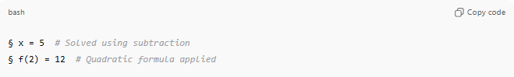
§ x = 5 # Solved using subtraction
§ f(2) = 12 # Quadratic formula applied

9. Field Value Format
# Source: AI Source: Provided by: [Data Path: Persons Table -> ID Column: 1, Name_En Column: Motasem Essam] -> From: [ChatGPT] on [7/14/2025]
- Each field starts with * (asterisk + space).
- Field name is written exactly as defined in the schema (e.g., Emulator Name, StoreDate).
- Field name is followed by a colon : and a space.
- Field value is written after the colon.
  - If Single Value → write as plain text.
  - If Multiple Values → separate with commas or line breaks.
  - If Nested Lists / Numbered Outlines → indent with - or numbers under the field.
  - If Yes/No → use Yes or No.
  - If Date/Time → use consistent format, e.g., YYYY-MM-DD HH:MM.
  - If Math → use explicit expressions (e.g., 5 * 30 = 150).
- Maintain the order of fields as listed in the schema (Optional).
- If a value is empty or unknown, either skip the field or write N/A.
- At the start of each cell, include a line for record folder/database/table location only if it exists; if the record has no folder, database, or table, omit this line entirely. This line represents the Data Path of folder/database/table location, after that, continue writing each field in the standard Field Value Format.
Data Path Format: 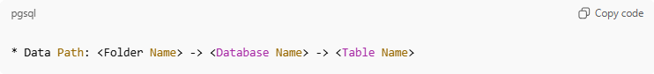
* Data Path: <Folder Name> -> <Database Name> -> <Table Name>

🔹 Example (Emulator)
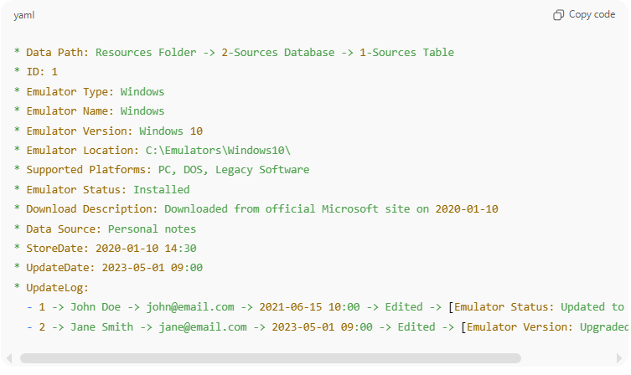
* Data Path: Resources Folder -> 2-Sources Database -> 1-Sources Table
* ID: 1
* Emulator Type: Windows
* Emulator Name: Windows
* Emulator Version: Windows 10
* Emulator Location: C:\Emulators\Windows10\
* Supported Platforms: PC, DOS, Legacy Software
* Emulator Status: Installed
* Download Description: Downloaded from official Microsoft site on 2020-01-10
* Data Source: Personal notes
* StoreDate: 2020-01-10 14:30
* UpdateDate: 2023-05-01 09:00
* UpdateLog:
- 1 -> John Doe -> john@email.com -> 2021-06-15 10:00 -> Edited -> [Emulator Status: Updated to Installed]
- 2 -> Jane Smith -> jane@email.com -> 2023-05-01 09:00 -> Edited -> [Emulator Version: Upgraded to Windows 10]

10. Mixed Format
# Source: AI Source: Provided by: [Data Path: Persons Table -> ID Column: 1, Name_En Column: Motasem Essam] -> From: [ChatGPT] on [7/14/2025]
- A Mixed Entry is created when two or more existing Cell Entry Fill rules are combined in the same data cell, document, or structured block.
- It allows flexibility to represent complex data where one rule alone is not sufficient.
- The mix is declared explicitly with the syntax:
- mix(RuleName1, RuleName2, …)
- Each included rule applies fully inside the same entry.
Rules
- Naming
  - Always start with mix(...) followed by the names of the chosen rules.
  - Example: mix(Sequential Content, Notes)
- Order of Application
  - Rules are applied in the order listed.
  - Example: mix(Numbered Outlines, Notes, Heading Format) means the main content follows numbered outlines, then notes and headings can be attached.
- Scalability
  - mix() can take 2 or more arguments, not limited to two.
- Flexibility Across Domains
  - Works for documents, courses, databases, knowledge bases, or books.
  - Use when content needs hierarchy + notes, or multiple values + sources, etc.

Example 1:
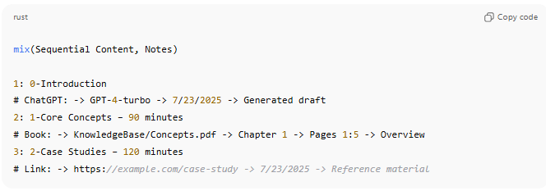
mix(Sequential Content, Notes)

1: 0-Introduction
# ChatGPT: -> GPT-4-turbo -> 7/23/2025 -> Generated draft
2: 1-Core Concepts – 90 minutes
# Book: -> KnowledgeBase/Concepts.pdf -> Chapter 1 -> Pages 1:5 -> Overview
3: 2-Case Studies – 120 minutes
# Link: -> https://example.com/case-study -> 7/23/2025 -> Reference material
Example 2:
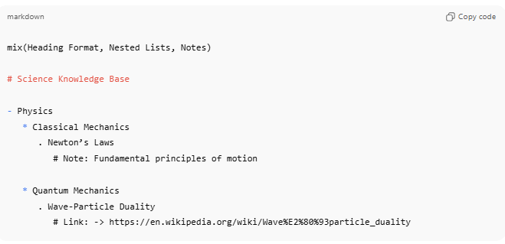
mix(Heading Format, Nested Lists, Notes)

# Science Knowledge Base

- Physics
* Classical Mechanics
. Newton’s Laws
# Note: Fundamental principles of motion

* Quantum Mechanics
. Wave-Particle Duality
# Link: -> https://en.wikipedia.org/wiki/Wave%E2%80%93particle_duality

👉 This way, the Mixed Entry Rule acts like a final universal layer that can combine any two or more previous types into one flexible structure.

2-Cell Entry Order
# Source: AI Source: Provided by: [Data Path: Persons Table -> ID Column: 1, Name_En Column: Motasem Essam] -> From: [ChatGPT] on [7/14/2025]

✅ Filling a Cell with Ordered Values
# Source: AI Source: Provided by: [Data Path: Persons Table -> ID Column: 1, Name_En Column: Motasem Essam] -> From: [ChatGPT] on [7/14/2025]
- When entering items that need both arrangement number and order number, use this format:
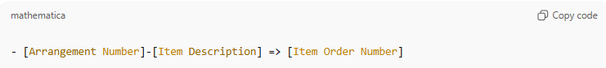
- [Arrangement Number]-[Item Description] => [Item Order Number]

- The Arrangement Number (left side, after first hyphen) shows the sequence in the list.
- The item Order Number (right side, after =>) shows the execution/finish/appear order of the item.
- ID remains optional and used only for relational reference (child → parent).

Example:
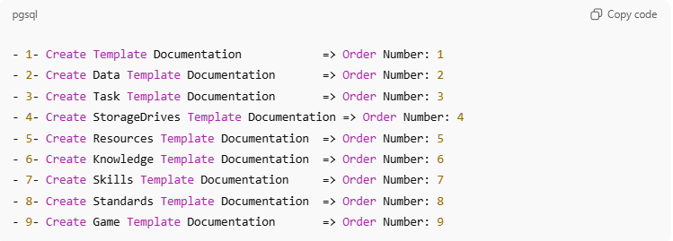
- 1- Create Template Documentation => Order Number: 1
- 2- Create Data Template Documentation => Order Number: 2
- 3- Create Task Template Documentation => Order Number: 3
- 4- Create StorageDrives Template Documentation => Order Number: 4
- 5- Create Resources Template Documentation => Order Number: 5
- 6- Create Knowledge Template Documentation => Order Number: 6
- 7- Create Skills Template Documentation => Order Number: 7
- 8- Create Standards Template Documentation => Order Number: 8
- 9- Create Game Template Documentation => Order Number: 9

(ID omitted — optional) 👍

✅ Options for Writing a Task
# Source: AI Source: Provided by: [Data Path: Persons Table -> ID Column: 1, Name_En Column: Motasem Essam] -> From: [ChatGPT] on [7/14/2025]
You can add both numbers together, or keep them separate, depending on how much clarity you want.
- Arrangement Number Only (left):
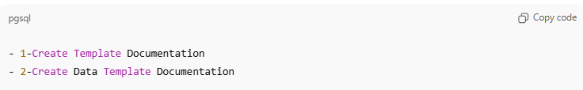
- 1-Create Template Documentation
- 2-Create Data Template Documentation
- Task Order Number Only (right):
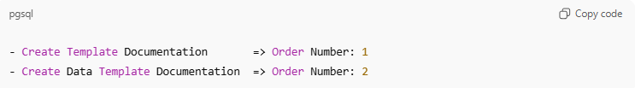
- Create Template Documentation => Order Number: 1
- Create Data Template Documentation => Order Number: 2
- Both Together (left + right):
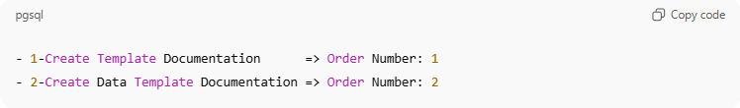
- 1-Create Template Documentation => Order Number: 1
- 2-Create Data Template Documentation => Order Number: 2
- Both Together (left + right) + Id :
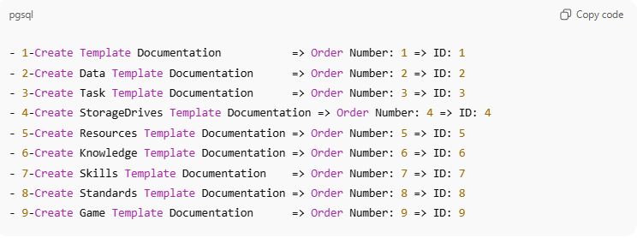
- 1-Create Template Documentation => Order Number: 1 => ID: 1
- 2-Create Data Template Documentation => Order Number: 2 => ID: 2
- 3-Create Task Template Documentation => Order Number: 3 => ID: 3
- 4-Create StorageDrives Template Documentation => Order Number: 4 => ID: 4
- 5-Create Resources Template Documentation => Order Number: 5 => ID: 5
- 6-Create Knowledge Template Documentation => Order Number: 6 => ID: 6
- 7-Create Skills Template Documentation => Order Number: 7 => ID: 7
- 8-Create Standards Template Documentation => Order Number: 8 => ID: 8
- 9-Create Game Template Documentation => Order Number: 9 => ID: 9

✅ With Nested Lists Example
Perfect 👍 I’ll restructure it exactly like you want, with the options clearly labeled.

🔹 With Nested Lists Example
Option 1 – Arrangement Number Only (Left):
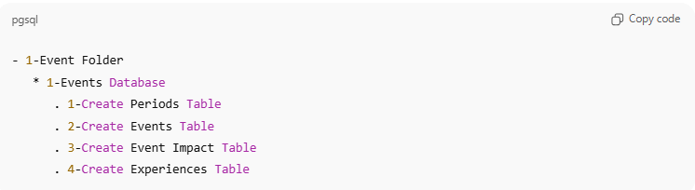
- 1-Event Folder
* 1-Events Database
. 1-Create Periods Table
. 2-Create Events Table
. 3-Create Event Impact Table
. 4-Create Experiences Table
Option 2 – Order Number Only (Right):
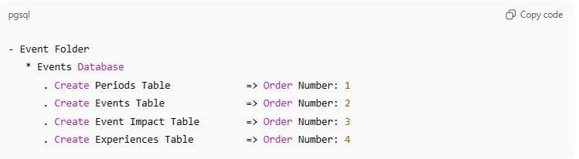
- Event Folder
* Events Database
. Create Periods Table => Order Number: 1
. Create Events Table => Order Number: 2
. Create Event Impact Table => Order Number: 3
. Create Experiences Table => Order Number: 4

Option 3 – Both (Arrangement + Task Order):
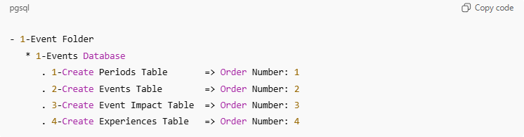
- 1-Event Folder
* 1-Events Database
. 1-Create Periods Table => Order Number: 1
. 2-Create Events Table => Order Number: 2
. 3-Create Event Impact Table => Order Number: 3
. 4-Create Experiences Table => Order Number: 4

Option 4 – Both Together (left + right) + Id :
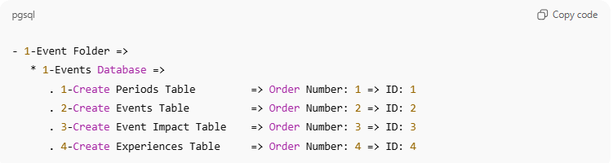
- 1-Event Folder =>
* 1-Events Database =>
. 1-Create Periods Table => Order Number: 1 => ID: 1
. 2-Create Events Table => Order Number: 2 => ID: 2
. 3-Create Event Impact Table => Order Number: 3 => ID: 3
. 4-Create Experiences Table => Order Number: 4 => ID: 4

✅ Flexible Numbering Rule in Nested Lists
# Source: AI Source: Provided by: [Data Path: Persons Table -> ID Column: 1, Name_En Column: Motasem Essam] -> From: [ChatGPT] on [7/14/2025]
Definition:
Arrangement Numbers (left), Task Order Numbers (right), or Both can be applied:
- To only one level (parent, child, or grandchild).
- Or to multiple levels at the same time.
This makes the system flexible: you can highlight just the main items, only the detailed tasks, or every level depending on your needs.
Examples
Got it ✅ I’ll rewrite your Flexible Numbering Rule Examples with the correct case names and order.

🔹 Flexible Numbering Rule in Nested Lists
Definition:
Arrangement Numbers (left), Task Order Numbers (right), or Both can be applied:
- To only one level (parent, child, or grandchild).
- Or to multiple levels at the same time.

Examples
Great 👍 I’ll add Case 6 to show a mixed numbering style: left numbers on Level 1, right numbers on Level 3.

🔹 Flexible Numbering Rule in Nested Lists
Definition:
Arrangement Numbers (left), Task Order Numbers (right), or Both can be applied:
- To only one level (parent, child, or grandchild).
- Or to multiple levels at the same time.

Examples
Case 1 – Numbers only on Level 1 (top level):
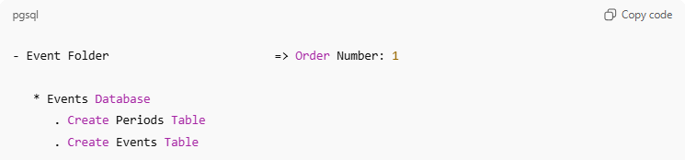
- Event Folder => Order Number: 1
* Events Database
. Create Periods Table
. Create Events Table

Case 2 – Numbers only on Level 2 (child level):
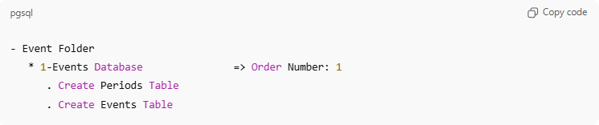
- Event Folder
* 1-Events Database => Order Number: 1
. Create Periods Table
. Create Events Table

Case 3 – Left numbers on Level 1 and Level 2:
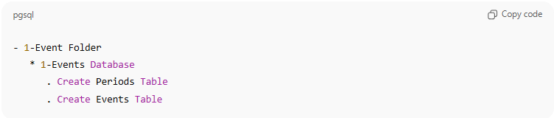
- 1-Event Folder
* 1-Events Database
. Create Periods Table
. Create Events Table
Case 4 – Right numbers on Level 2 and Level 3:
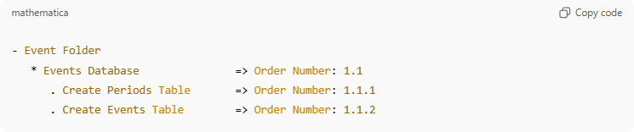
- Event Folder
* Events Database => Order Number: 1.1
. Create Periods Table => Order Number: 1.1.1
. Create Events Table => Order Number: 1.1.2

Case 5 – Numbers on All Levels:
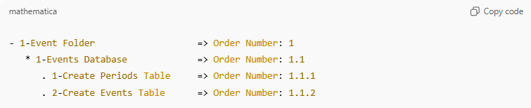
- 1-Event Folder => Order Number: 1
* 1-Events Database => Order Number: 1.1
. 1-Create Periods Table => Order Number: 1.1.1
. 2-Create Events Table => Order Number: 1.1.2
Case 6 – Mixed: Left on Level 1, Right on Level 3:
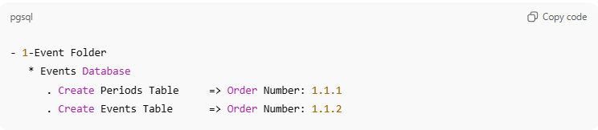
- 1-Event Folder
* Events Database
. Create Periods Table => Order Number: 1.1.1
. Create Events Table => Order Number: 1.1.2
Note
You can have other cases or variations depending on your needs.
These 6 cases are provided just to make the rule clear and easy to follow.

👉 This way it’s super clear: you can pick only left, only right, or both depending on how much detail you need.

5-Data Column

Knowledge Base

1-What is Data Column
# Source: AI Source: Provided by: [Data Path: Persons Table -> ID Column: 1, Name_En Column: Motasem Essam] -> From: [ChatGPT] on [7/14/2025]
A Data Column is one of the vertical divisions in a table or database that groups all the values of the same type (field) across different records (rows).

Rules and Guidelines

1-Commons columns
# Source: AI Source: Provided by: [Data Path: Persons Table -> ID Column: 1, Name_En Column: Motasem Essam] -> From: [ChatGPT] on [7/14/2025]
- ID
- Categories
- SubCategories
- SubSubCategories
- Collection
- CreatedBy
- StoreDate
- UpdateDate
- UpdateLog

- ID:
A unique identifier for each record or entry. It ensures that every row can be distinguished from the others.

- Categories:
The highest-level grouping used to classify the data. For example, in a product database, categories might be Electronics, Clothing, Furniture.
•
- SubCategories:
A more specific grouping within a category. For example, under Electronics, subcategories could be Mobile Phones, Laptops, Televisions.

- SubSubCategories:
A deeper level of classification, used for further specialization. For example, under Mobile Phones → Android Phones, iPhones.

- Collection:
A flexible grouping or set that brings together related items across categories and subcategories. For example, a Summer Collection may include clothing, accessories, and shoes from different subcategories.

- CreatedBy:
Name and contact information of the person who created the record (e.g., email, phone, or other identifier).
- StoreDate:
The date and time when the record was originally created or stored in the database. Useful for tracking when the data first entered the system.

- UpdateDate:
The date and time when the record was last modified. This helps in monitoring recent changes or edits to the data, initially filled with the same value as StoreDate when the record is first created, and should be updated automatically whenever any changes are made to the record.

- UpdateLog:
A detailed record of all changes made to the entry, including who made the change, when it was made, the type of action (Create, Update, Delete), and which fields were affected.

2-Column Entry Order
# Source: AI Source: Provided by: [Data Path: Persons Table -> ID Column: 1, Name_En Column: Motasem Essam] -> From: [ChatGPT] on [7/14/2025]
Rule 1: Sequential Numbering (Flat List / Column Order)
• Use simple sequential numbers to order items in a column or list.
• No prefix adaptation is needed; just number the items in order:
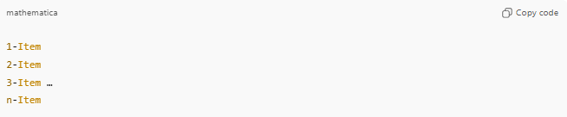
1-Item
2-Item
3-Item …
n-Item
Example:
- 7 items:
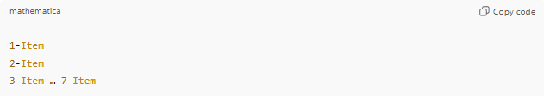
  - 1-Item
  - 2-Item
  - 3-Item … 7-Item

- 12 items:
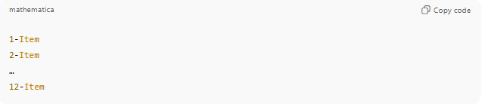
  - 1-Item
  - 2-Item
  - …
  - 12-Item

Rule 2: Hierarchical / Tree Order (Multi-level Items)
• Use numeric dot notation to indicate parent-child relationships and ordering of items in a tree structure.
• Format: 0.3.1.0.4
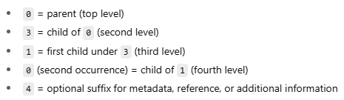
- 0 = parent (top level)
- 3 = child of 0 (second level)
- 1 = first child under 3 (third level)
- 0 (second occurrence) = child of 1 (fourth level)
- 4 = optional suffix for metadata, reference, or additional information
• Rules for numbering items within a parent:
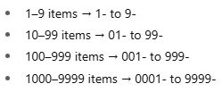
- 1–9 items → 1- to 9-
- 10–99 items → 01- to 99-
- 100–999 items → 001- to 999-
- 1000–9999 items → 0001- to 9999-
Examples:
- If 3 has 20 children:
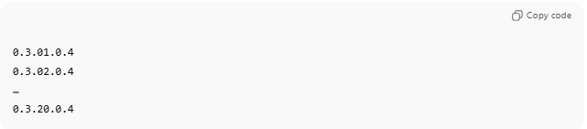
  - 0.3.01.0.4
  - 0.3.02.0.4
  - …
  - 0.3.20.0.4
- If 3 has 150 children:
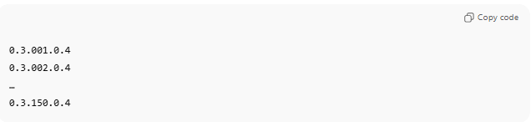
  - 0.3.001.0.4
  - 0.3.002.0.4
  - …
  - 0.3.150.0.4

✅ Notes:
- Use Sequential Numbering for flat lists and Tree Order for hierarchical relationships.
- Each child in Tree Order can itself have multiple children, allowing unlimited nested levels.

6-Data Template and Representation

Knowledge Base

1-Data

Data Template

Definition
# Source: AI Source: Provided by: [Data Path: Persons Table -> ID Column: 1, Name_En Column: Motasem Essam] -> From: [ChatGPT] on [7/14/2025]
A Data Template is a predefined structure that specifies how data should be entered, stored, or exchanged in a database or system.
It’s like a form or schema that enforces consistency.

🔹 Key Features of a Data Template
# Source: AI Source: Provided by: [Data Path: Persons Table -> ID Column: 1, Name_En Column: Motasem Essam] -> From: [ChatGPT] on [7/14/2025]
- Defines fields/attributes (e.g., EmployeeID, Name, Salary)
- Defines data types (text, number, date, etc.)
- May include rules/constraints (must be unique, must not be empty)
- Ensures standardization when multiple people/systems handle the data

🔹 Examples of Data Templates

1. SQL Table Template (Schema)
# Source: AI Source: Provided by: [Data Path: Persons Table -> ID Column: 1, Name_En Column: Motasem Essam] -> From: [ChatGPT] on [7/14/2025]
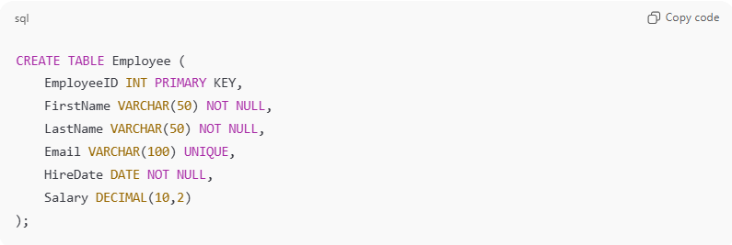
CREATE TABLE Employee (
EmployeeID INT PRIMARY KEY,
FirstName VARCHAR(50) NOT NULL,
LastName VARCHAR(50) NOT NULL,
Email VARCHAR(100) UNIQUE,
HireDate DATE NOT NULL,
Salary DECIMAL(10,2)
);
➡️ This is a template (blueprint) for all employee records in the database.

2. CSV/Excel Template (For Data Entry)
# Source: AI Source: Provided by: [Data Path: Persons Table -> ID Column: 1, Name_En Column: Motasem Essam] -> From: [ChatGPT] on [7/14/2025]
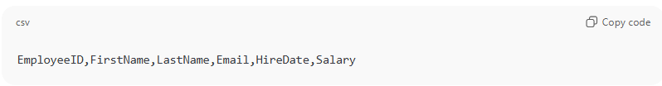
EmployeeID,FirstName,LastName,Email,HireDate,Salary
Users must fill rows according to this template before uploading to a database.

3. Form Template (Application UI)
# Source: AI Source: Provided by: [Data Path: Persons Table -> ID Column: 1, Name_En Column: Motasem Essam] -> From: [ChatGPT] on [7/14/2025]
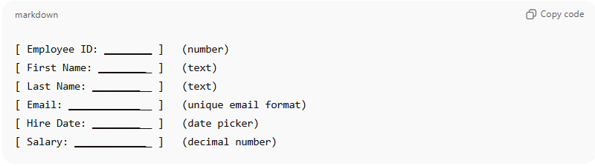
[ Employee ID: ________ ] (number)
[ First Name: _________ ] (text)
[ Last Name: __________ ] (text)
[ Email: ______________ ] (unique email format)
[ Hire Date: __________ ] (date picker)
[ Salary: _____________ ] (decimal number)
➡️ Enforces the same blueprint as the database schema.

4. Microsoft Access Data Templates (Built-In Blueprints) ✅
# Source: AI Source: Provided by: [Data Path: Persons Table -> ID Column: 1, Name_En Column: Motasem Essam] -> From: [ChatGPT] on [7/14/2025]
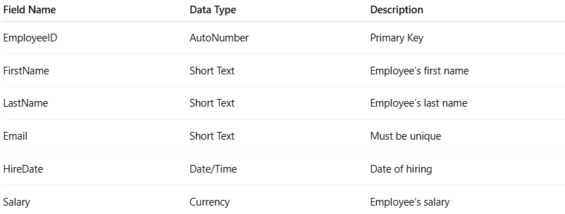
Field Name | Data Type | Description
EmployeeID | AutoNumber | Primary Key
FirstName | Short Text | Employee’s first name
LastName | Short Text | Employee’s last name
Email | Short Text | Must be unique
HireDate | Date/Time | Date of hiring
Salary | Currency | Employee’s salary
➡️ This table design is the data template (blueprint) in Access. It ensures that every employee record follows the same structure.

Data Representation
# Source: AI Source: Provided by: [Data Path: Persons Table -> ID Column: 1, Name_En Column: Motasem Essam] -> From: [ChatGPT] on [7/14/2025]

Definition
Data Representation means how data is structured, formatted, and stored so that computers, databases, and humans can understand, process, and exchange it.

🔹 Major Types of Data Representation

1. Tabular (Relational)
# Source: AI Source: Provided by: [Data Path: Persons Table -> ID Column: 1, Name_En Column: Motasem Essam] -> From: [ChatGPT] on [7/14/2025]
- Format: Rows and Columns (Tables)
- Tools/Systems: SQL Databases, Access, Excel, CSV
- Use Case: Structured, relational data
- ✅ Example: Employee table in a database
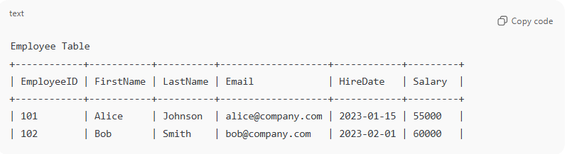
Employee Table
+------------+-----------+----------+-------------------+------------+---------+
| EmployeeID | FirstName | LastName | Email | HireDate | Salary |
+------------+-----------+----------+-------------------+------------+---------+
| 101 | Alice | Johnson | alice@company.com | 2023-01-15 | 55000 |
| 102 | Bob | Smith | bob@company.com | 2023-02-01 | 60000 |

2. Hierarchical (Tree-like)
# Source: AI Source: Provided by: [Data Path: Persons Table -> ID Column: 1, Name_En Column: Motasem Essam] -> From: [ChatGPT] on [7/14/2025]
- Format: Parent → Child relationships
- Tools/Systems: Early DBMS (IMS), XML files
- Use Case: Data that naturally fits trees (org charts, product categories)
- ✅ Example: XML <Employee><Name>...</Name></Employee>
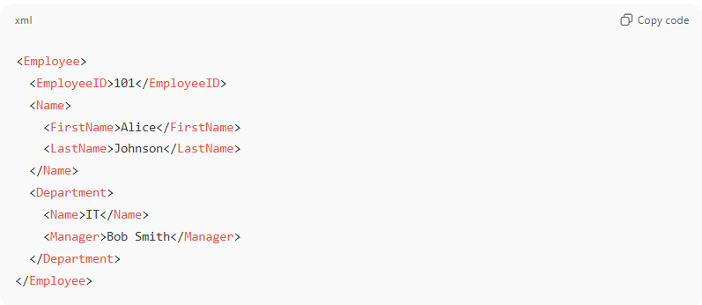
<Employee>
<EmployeeID>101</EmployeeID>
<Name>
<FirstName>Alice</FirstName>
<LastName>Johnson</LastName>
</Name>
<Department>
<Name>IT</Name>
<Manager>Bob Smith</Manager>
</Department>
</Employee>

3. Document-Oriented
# Source: AI Source: Provided by: [Data Path: Persons Table -> ID Column: 1, Name_En Column: Motasem Essam] -> From: [ChatGPT] on [7/14/2025]
- Format: JSON, BSON, or XML documents
- Tools/Systems: NoSQL databases (MongoDB, CouchDB, Firebase)
- Use Case: Semi-structured, schema-less, web/mobile apps
- ✅ Example: JSON object { "Name": "Alice", "Salary": 55000 }
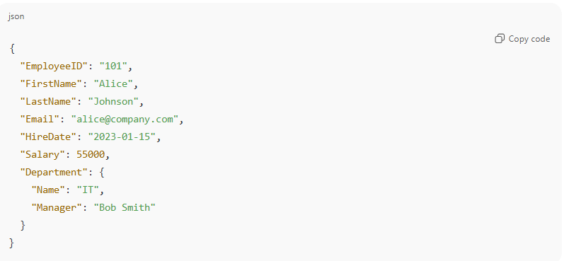
{
"EmployeeID": "101",
"FirstName": "Alice",
"LastName": "Johnson",
"Email": "alice@company.com",
"HireDate": "2023-01-15",
"Salary": 55000,
"Department": {
"Name": "IT",
"Manager": "Bob Smith"
}
}

4. Key–Value
# Source: AI Source: Provided by: [Data Path: Persons Table -> ID Column: 1, Name_En Column: Motasem Essam] -> From: [ChatGPT] on [7/14/2025]
- Format: Unique Key → Associated Value
- Tools/Systems: Redis, DynamoDB, Riak
- Use Case: Caching, session storage, high-performance lookups
- ✅ Example: "Employee101": "Alice Johnson"
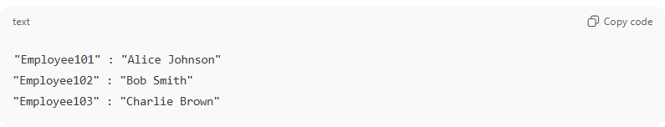
"Employee101" : "Alice Johnson"
"Employee102" : "Bob Smith"
"Employee103" : "Charlie Brown"

5. Graph-Based
# Source: AI Source: Provided by: [Data Path: Persons Table -> ID Column: 1, Name_En Column: Motasem Essam] -> From: [ChatGPT] on [7/14/2025]
- Format: Nodes (entities) + Edges (relationships)
- Tools/Systems: Neo4j, ArangoDB, OrientDB
- Use Case: Social networks, recommendation engines, fraud detection
- ✅ Example: Alice → FRIENDS_WITH → Bob
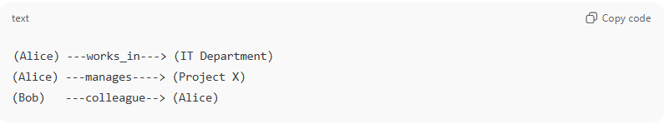
(Alice) ---works_in---> (IT Department)
(Alice) ---manages----> (Project X)
(Bob) ---colleague--> (Alice)

6. Columnar
# Source: AI Source: Provided by: [Data Path: Persons Table -> ID Column: 1, Name_En Column: Motasem Essam] -> From: [ChatGPT] on [7/14/2025]
- Format: Data stored by columns instead of rows
- Tools/Systems: Cassandra, HBase, Google Bigtable
- Use Case: Analytics, big data queries, OLAP
- ✅ Example: Instead of full rows, store all FirstNames together, all Salaries together.
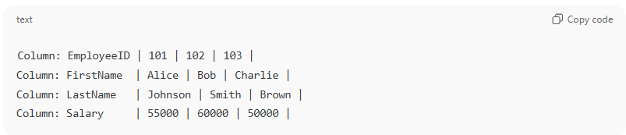
Column: EmployeeID | 101 | 102 | 103 |
Column: FirstName | Alice | Bob | Charlie |
Column: LastName | Johnson | Smith | Brown |
Column: Salary | 55000 | 60000 | 50000 |

7. Object-Oriented
# Source: AI Source: Provided by: [Data Path: Persons Table -> ID Column: 1, Name_En Column: Motasem Essam] -> From: [ChatGPT] on [7/14/2025]
- Format: Data stored as objects (with attributes & methods)
- Tools/Systems: Object databases (db4o, ObjectDB)
- Use Case: Applications using OOP languages directly with DB
- ✅ Example: Employee object with fields + behaviors
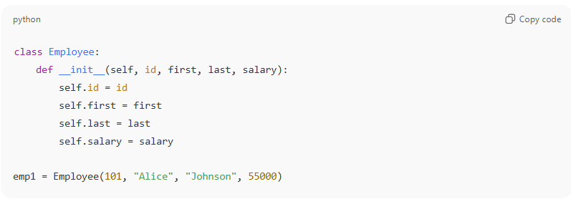
class Employee:
def __init__(self, id, first, last, salary):
self.id = id
self.first = first
self.last = last
self.salary = salary

emp1 = Employee(101, "Alice", "Johnson", 55000)

8. File-Based / Flat File
# Source: AI Source: Provided by: [Data Path: Persons Table -> ID Column: 1, Name_En Column: Motasem Essam] -> From: [ChatGPT] on [7/14/2025]
- Format: Plain text, CSV, or binary files
- Tools/Systems: Legacy systems, logs, data exchange
- Use Case: Simple storage, data migration
- ✅ Example: CSV file with employee records
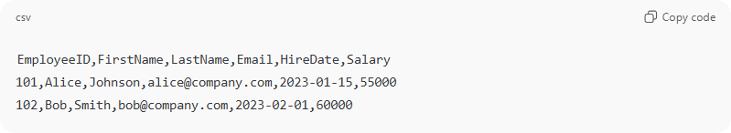
EmployeeID,FirstName,LastName,Email,HireDate,Salary
101,Alice,Johnson,alice@company.com,2023-01-15,55000
102,Bob,Smith,bob@company.com,2023-02-01,60000

✅ Summary Table
# Source: AI Source: Provided by: [Data Path: Persons Table -> ID Column: 1, Name_En Column: Motasem Essam] -> From: [ChatGPT] on [7/14/2025]
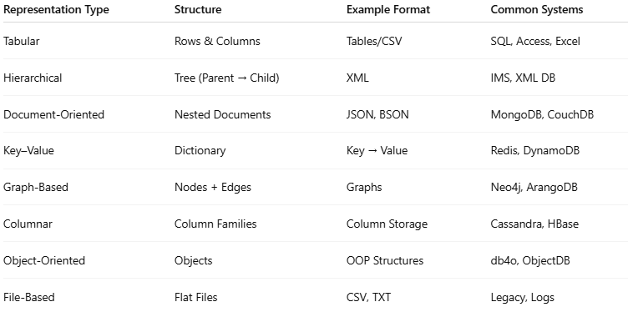
Representation Type | Structure | Example Format | Common Systems
Tabular | Rows & Columns | Tables/CSV | SQL, Access, Excel
Hierarchical | Tree (Parent → Child) | XML | IMS, XML DB
Document-Oriented | Nested Documents | JSON, BSON | MongoDB, CouchDB
Key–Value | Dictionary | Key → Value | Redis, DynamoDB
Graph-Based | Nodes + Edges | Graphs | Neo4j, ArangoDB
Columnar | Column Families | Column Storage | Cassandra, HBase
Object-Oriented | Objects | OOP Structures | db4o, ObjectDB
File-Based | Flat Files | CSV, TXT | Legacy, Logs

👉 So, Tabular, JSON, and XML are only 3 out of many possible data representation types.

✅ In short:
# Source: AI Source: Provided by: [Data Path: Persons Table -> ID Column: 1, Name_En Column: Motasem Essam] -> From: [ChatGPT] on [7/14/2025]
- Data Representation = The format/model in which data is organized (Tabular, JSON, XML, Graph, etc.).
- Data Template = The blueprint/rules that specify how that data must be structured and stored consistently.

Rules and Guidelines

1-Data Template
# Source: AI Source: Provided by: [Data Path: Persons Table -> ID Column: 1, Name_En Column: Motasem Essam] -> From: [ChatGPT] on [7/14/2025]
Each column or field in a Data Template must include the following elements:
- Field Name → The name of the column or data field.
- Data Type → The type of data the field stores (e.g., Short Text, Number, Date/Time, Currency, AutoNumber).
- Description → A brief explanation of what the field represents or its purpose.
- Cell Entry Fill Type → Defines the formatting style(s) allowed inside the cell.
⚠️ Note: A field can support more than one Cell Entry Fill Type, separated by commas.

Format
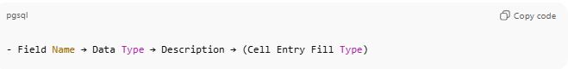
- Field Name → Data Type → Description → (Cell Entry Fill Type)

Examples
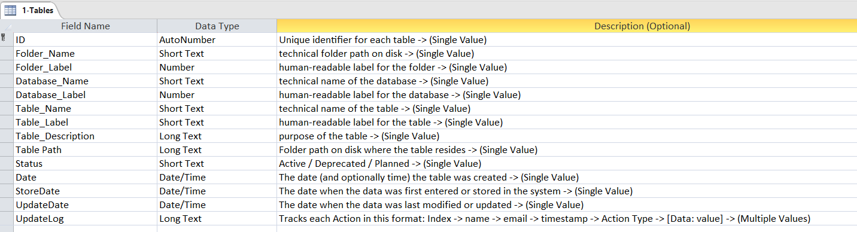
- ID → AutoNumber → Unique identifier for each table → (Single Value)
- Folder Name → Short Text → Technical folder path on disk → (Single Value)
- Folder Label → Number → Human-readable label for the folder → (Single Value)
- Database Name → Short Text → Technical name of the database → (Single Value)
- Database Label → Number → Human-readable label for the database → (Single Value)
- Table Name → Short Text → Technical name of the table → (Single Value)
- Table Label → Short Text → Human-readable label for the table → (Single Value)
- Table Description → Long Text → Purpose of the table → (Single Value)
- Table Path → Long Text → Folder path on disk where the table resides → (Single Value)
- Status → Short Text → Active / Deprecated / Planned → (Single Value)
- Date → Date/Time → The date (and optionally time) the table was created → (Single Value)
- StoreDate → Date/Time → The date when the data was first entered or stored in the system → (Single Value)
- UpdateDate → Date/Time → The date when the data was last modified or updated → (Single Value)
- UpdateLog → Long Text → Tracks each Action in this format: Index → name → email → timestamp → Action Type → [Data: value] → (Multiple Values)

7-UpdateLog

Knowledge Base

1-UpdateLog
# Source: AI Source: Provided by: [Data Path: Persons Table -> ID Column: 1, Name_En Column: Motasem Essam] -> From: [ChatGPT] on [7/14/2025]
The UpdateLog is a record or history of changes made to a data entry, task, or item in a database, document, or system. It keeps track of who performed an action, when it was performed, what type of action it was, and which fields or parts of the item were affected.
Purpose:
- To provide a complete history of changes for auditing or tracking purposes.
- To allow users to see who created or updated an item, and what exactly was changed.
- To support accountability and version control in data management.

Rules and Guidelines

1-Record UpdateLog

Rules for Writing UpdateLog Entries
# Source: AI Source: Provided by: [Data Path: Persons Table -> ID Column: 1, Name_En Column: Motasem Essam] -> From: [ChatGPT] on [7/14/2025]
Enter Number → User Information → Timestamp -> Action Type -> Fields Affected
- Entry Number → Each entry starts with a sequential number indicating its order in the log.
  - Example: 1 -> or 2 ->
- User Information → Include the full name and email of the person performing the action.
  - Format: Full Name -> email@example.com
- Timestamp → Record the date and time of the action.
  - Format: MM/DD/YYYY HH:MM:SS AM/PM (time is optional if only date is needed).
- Action Type → Specify the type of action performed on the item:
  - Create → when a new item is created
  - Update → when an existing item is modified
  - Delete → if an item is removed (if applicable)
- Fields Affected → List the fields that were created or modified:
  - [*] → all data has been entered
  - [*- Field1, Field2] → all data has been entered except the listed fields
  - [Field1, Field2] → only the listed fields were affected
  - Optional Values: You can include values for fields in the format FieldName: Value
    - Example: [TaskDescription: "Example text", TaskEndDate: 9/11/2025, Index: 3]
- Description (Optional) → A short note explaining the purpose or details of the action.
  - Format: Description: "text"
  - This field can be omitted if not needed.

Examples with Rules Applied

1. All data entered
# Source: AI Source: Provided by: [Data Path: Persons Table -> ID Column: 1, Name_En Column: Motasem Essam] -> From: [ChatGPT] on [7/14/2025]
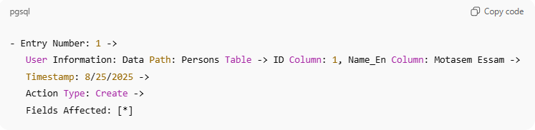
- Entry Number: 1 ->
User Information: Data Path: Persons Table -> ID Column: 1, Name_En Column: Motasem Essam ->
Timestamp: 8/25/2025 ->
Action Type: Create ->
Fields Affected: [*]

2. All data except some fields
# Source: AI Source: Provided by: [Data Path: Persons Table -> ID Column: 1, Name_En Column: Motasem Essam] -> From: [ChatGPT] on [7/14/2025]
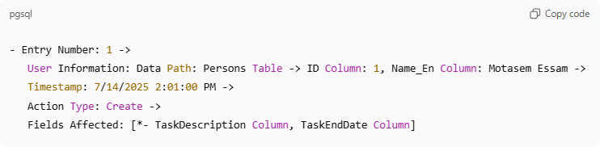
- Entry Number: 1 ->
User Information: Data Path: Persons Table -> ID Column: 1, Name_En Column: Motasem Essam ->
Timestamp: 7/14/2025 2:01:00 PM ->
Action Type: Create ->
Fields Affected: [*- TaskDescription Column, TaskEndDate Column]

3. Only listed fields updated
# Source: AI Source: Provided by: [Data Path: Persons Table -> ID Column: 1, Name_En Column: Motasem Essam] -> From: [ChatGPT] on [7/14/2025]
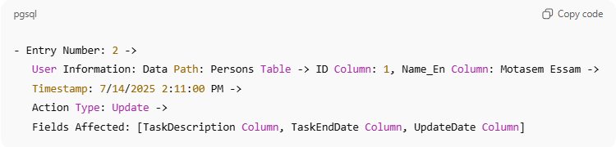
- Entry Number: 2 ->
User Information: Data Path: Persons Table -> ID Column: 1, Name_En Column: Motasem Essam ->
Timestamp: 7/14/2025 2:11:00 PM ->
Action Type: Update ->
Fields Affected: [TaskDescription Column, TaskEndDate Column, UpdateDate Column]

4. Listed fields with optional values
# Source: AI Source: Provided by: [Data Path: Persons Table -> ID Column: 1, Name_En Column: Motasem Essam] -> From: [ChatGPT] on [7/14/2025]
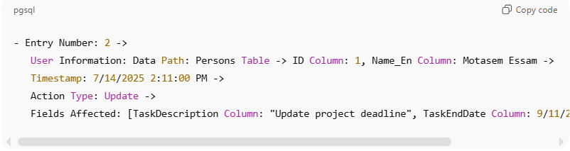
- Entry Number: 2 ->
User Information: Data Path: Persons Table -> ID Column: 1, Name_En Column: Motasem Essam ->
Timestamp: 7/14/2025 2:11:00 PM ->
Action Type: Update ->
Fields Affected: [TaskDescription Column: "Update project deadline", TaskEndDate Column: 9/11/2025, Index Column: 3]

5. Example with Description
# Source: AI Source: Provided by: [Data Path: Persons Table -> ID Column: 1, Name_En Column: Motasem Essam] -> From: [ChatGPT] on [7/14/2025]
- Entry Number: 2 ->
User Information: Motasem Essam -> motasem@example.com ->
Timestamp: 7/14/2025 2:11:00 PM ->
Action Type: Update ->
Fields Affected: [TaskEndDate Column: 9/11/2025, Index Column: 3] ->
Description: "Updated project deadline and adjusted task index"

8-Table Value Dictionary (TVD)

Knowledge Base

1-What is Table Value Dictionary (TVD)
# Source: AI Source: Provided by: [Data Path: Persons Table -> ID Column: 1, Name_En Column: Motasem Essam] -> From: [ChatGPT] on [11/23/2025]
A Table Value Dictionary (TVD) is a structured file that defines allowed values for selected columns in a single database table.
Each table has its own TVD, and only columns requiring controlled values need to be included.
Purpose of the TVD
- Centralizes allowed values for table columns.
- Ensures data consistency and validation across systems.
- Supports dashboards, APIs, AI applications, and audits.
- Provides a single source of truth for column value definitions.
- Optionally indicates where each value exists in the table using row references.

Rules & Guidelines

1-TVD Structure

1-TVD File Structure
# Source: AI Source: Provided by: [Data Path: Persons Table -> ID Column: 1, Name_En Column: Motasem Essam] -> From: [ChatGPT] on [11/23/2025]
- One table per TVD file.
- Heading 1 (H1): Table Name
- Heading 2 (H2): Column Name (only columns with controlled values).
- Only include only the columns that have defined allowed values.
- Under each column:
  - value → the actual stored value in the database
  - label → human-readable label (can be numeric or text, different from value)
  - description → optional explanation
  - row_range (optional) → specifies where the value exists in the table; can be individual rows, ranges, or combinations (e.g., 1:3,5,6)
Note: Columns without restrictions do not need to appear in the TVD.

2-Categories Rules
# Source: AI Source: Provided by: [Data Path: Persons Table -> ID Column: 1, Name_En Column: Motasem Essam] -> From: [ChatGPT] on [11/23/2025]
- List all allowed values clearly under each column.
- Declare the data type for each column.
- Optionally include label, description, row_range, or source.

3-Row Range Rules
# Source: AI Source: Provided by: [Data Path: Persons Table -> ID Column: 1, Name_En Column: Motasem Essam] -> From: [ChatGPT] on [11/23/2025]
- row_range is optional.
- Can use individual rows, e.g., 5,7,12
- Can use continuous ranges, e.g., 1:3 → rows 1,2,3
- Can combine both, e.g., 1:3,5,6 → rows 1,2,3,5,6
- Useful for audits, tracking, and documentation.

4-Consistency Rules
# Source: AI Source: Provided by: [Data Path: Persons Table -> ID Column: 1, Name_En Column: Motasem Essam] -> From: [ChatGPT] on [11/23/2025]
- No duplicate values per column.
- Values must match declared type.
- Strings should follow consistent casing rules.

5-Maintenance Rules
# Source: AI Source: Provided by: [Data Path: Persons Table -> ID Column: 1, Name_En Column: Motasem Essam] -> From: [ChatGPT] on [11/23/2025]
- Increment TVD version when allowed values change.
- Deprecated values should be marked, not deleted immediately.
- Update row_range as data evolves.

6-Example Table Value Dictionary (TVD)
# Source: AI Source: Provided by: [Data Path: Persons Table -> ID Column: 1, Name_En Column: Motasem Essam] -> From: [ChatGPT] on [11/23/2025]
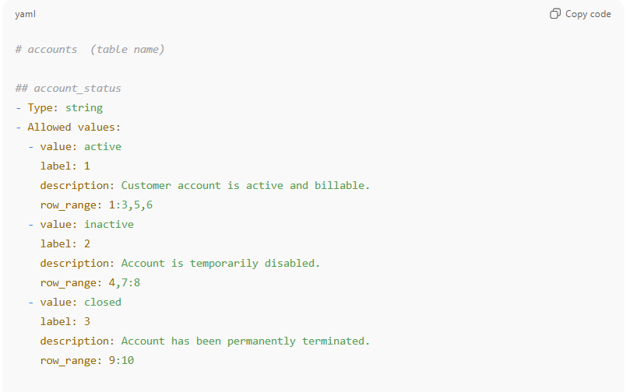
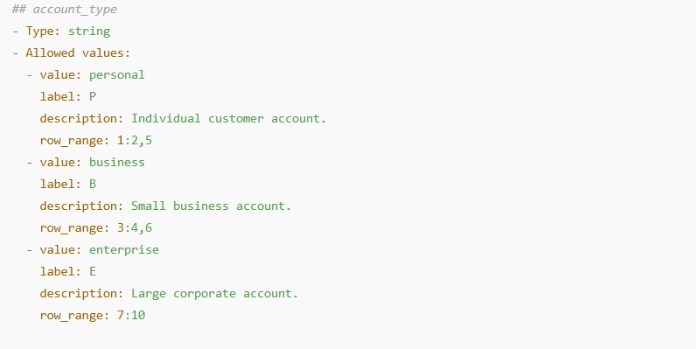
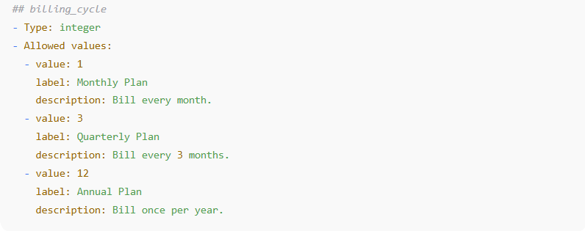
# accounts (table name)
## account_status
- Type: string
- Allowed values:
- value: active
label: 1
description: Customer account is active and billable.
row_range: 1:3,5,6
- value: inactive
label: 2
description: Account is temporarily disabled.
row_range: 4,7:8
- value: closed
label: 3
description: Account has been permanently terminated.
row_range: 9:10

## account_type
- Type: string
- Allowed values:
- value: personal
label: P
description: Individual customer account.
row_range: 1:2,5
- value: business
label: B
description: Small business account.
row_range: 3:4,6
- value: enterprise
label: E
description: Large corporate account.
row_range: 7:10

## billing_cycle
- Type: integer
- Allowed values:
- value: 1
label: Monthly Plan
description: Bill every month.
- value: 3
label: Quarterly Plan
description: Bill every 3 months.
- value: 12
label: Annual Plan
description: Bill once per year.

✅ Key Features Now Included
- value → actual database value
- label → human-readable or numeric, can differ from value
- description → optional explanation
- row_range → optional, supports individual rows, ranges, or combinations like 1:3,5,6

